Elaboration Phase

CIS 320-02

Team: BusinessFirst

**Alexander Welsh, Dalton Karl, Anthony Striepe, Jrew Simpson, La’Daysha Wade**

Table of Contents

Table of Contents 2

System Requirements: 6

Use Case Diagrams and Narratives: 9

Use Case 1-5 Diagram Music Showcase 9

Use Case 1-5 Diagram Narrative 9

Use Case 6-7 Diagram Program/Workshop Info Management Group 10

Use Case 6-7 Diagram Narrative 10

Use Case 8-9 Diagram Contact Form Group 11

Use Case 8-9 Diagram Narrative 11

Use Case 10-11 Contact Form 12

Use Case 12-16 Diagram Donation Process 13

Use Case 12-16 Diagram Narrative 13

Use Case 17-18 Diagram Review System 14

Use Case 17-18 Diagram Narrative 14

Use Case 19-20 Diagram Social Media Integration System 15

Use Case 19-20 Diagram Narrative 15

Use Case 21-22 Diagram Sponsors Showcase 16

Use Case 21-22 Diagram Narrative 16

Use Case 23-24 Diagram Mission Statement 17

Use Case 23-24 Diagram Narrative 17

Use Case 25-27 Diagram Narrative 18

Use Case 28-31 Diagram Narrative 19

Use Case 32 & 34 Diagram Website Interface: 20

Use Case 33 Diagram Update Volunteer Hours 21

Trace Matrix 22

Trace Matrix Narrative 22

Use Case Descriptions: 23

Use Case 1: User Views Song Catalog 23

Use Case 2: User Listen To Songs 24

Use Case 3: Manage Song Catalog 25

Use Case 4: Change Song Volume 26

Use Case 5: Share a Listed Song 27

Use Case 6 View Program/Workshop Info: 28

Use Case 7 Modify Program/Workshop Info: 29

Use Case 8 Modify Layout / Fields of Contact Form 31

Use Case 9 Fill Out Fields in Contact Form: 33

Use Case 10-11 Contact Form: 34

Use Case 12 Check/Uncheck Recurring Donation Box: 36

Use Case 13 Donate with PayPal: 37

Use Case 14 Donate with Debit or Credit Card: 38

Use Case 15 Donate Submit Button: 39

Use Case 16 Accept Donations: 40

Use Case 17: Change Reviews 41

Use Case 18: View Reviews 43

Use Case 19: View Social Media 44

Use Case 20: Social Media Connection 45

Use Case 21: View Sponsors 46

Use Case 22: Update Sponsor Display 47

Use Case 23: View Mission Statement 49

Use Case 24: Update Mission Statement 50

Use Case 25: View Application Page 51

Use Case 26: Filling Out Application 52

Use Case 27: Reviews Applications 54

Use Case 28: View Calendar 55

Use Case 29: Interacts with Calendar 56

Use Case 30: Clicks RSVP on Calendar 57

Use Case 31: Makes Changes to Calendar 58

Use Case 32: View Volunteer Hours 59

Use Case 33: Updates Volunteer Hours Display 60

Use Case 34: Newsletter Signup Button 61

Sequence Diagrams: 62

Sequence Diagram #1-5 Music Showcase 62

Sequence Diagram #6-7 Modify Program/Workshop Info 63

Sequence Diagram #8-9 Modify Layout/Fields of Contact Form 64

Sequence Diagram #10-11 65

Sequence Diagram #12-16 Donation System 65

#17-18 Reviews Sequence Diagram 66

#19-20 Social Media Sequence Diagram 66

#21-22 Sponsors Sequence Diagram 67

#23-24 Mission Statement Sequence Diagram 68

#25-27 Application Sequence Diagram 69

#28-31 Calendar Sequence Diagram 70

Sequence Diagram #32-34 71

Class Diagram Model 72

Class Diagram Narrative: 72

Database Design: 74

Database Narrative 75

Database Definitions: 76

User Interface Navigation Diagram: 83

Screen Layouts: 83

Contact Form 83

Newsletter Form 84

RSVP Form 85

Application Form 86

3.3B Data Output Screens 86

Contact/Application Submissions 86

Newsletter Submissions 87

RSVP Submissions 87

Application Submissions 88

Physical Architecture Design: 89

Initial Design View 90

Realistic Design View 91

Design Procedures for Security Concerns and Non-Functional Requirements: 92

Gantt Chart 94

Elaboration Phase Prototype: 95

# System Requirements:

The system that we are creating has many functions that it needs to be able to perform in order to work properly and achieve the desired outcome of our client. These functions are separated into functional and non-functional based on what they aim to accomplish. The functional requirements are those that need to be able to perform while being interacted with in some way. The nonfunctional requirements are those that should function mostly independently of other processes. Our system mainly includes functional requirements, meaning that it needs to be highly interactive to be operational.

**Functional Requirements**  
Event Calendar

ID: SR001 – The event calendar shall display upcoming events.

ID: SR002 – The event calendar shall display volunteer opportunities.

ID: SR003 – The event calendar shall allow users to RSVP.

ID: SR004 – The event calendar shall send users event reminders.

Volunteer Sign-Up

ID: SR005 – The volunteer sign-up shall facilitate the process for users to register.

ID: SR006 – The volunteer sign-up shall automatically confirm registrations.

Mobile Optimization

ID: SR007 – The mobile optimization shall have a responsive design for mobile users.

ID: SR008 – The mobile optimization shall maintain useability without sacrificing functionality.

Content Management System

ID: SR009 – The content management system shall empower staff to easily update blogs.

ID: SR010 – The content management system shall empower staff to easily update events.

ID: SR011 – The content management system shall empower staff to easily update project reports.

ID: SR012 – The content management system shall require no technical expertise.

Project Showcase

ID: SR013 – The project showcase shall highlight current projects.

ID: SR014 – The project showcase shall highlight completed projects.

ID: SR015 – The project showcase shall increase transparency.

ID: SR016 – The project showcase shall increase community engagement.

Social Media Integration

ID: SR017 – The social media integration shall integrate social media links.

ID: SR018 – The social media integration shall integrate social media feeds.

ID: SR019 – The social media integration shall improve engagement.

ID: SR020 – The social media integration shall improve visibility.

Newsletter Sign-Up

ID: SR021 – The newsletter sign-up shall provide users with the ability to subscribe to email updates.

ID: SR022 – The newsletter sign-up shall ensure supporters are informed about the latest news.

ID: SR023 – The newsletter sign-up shall ensure supporters are informed about the latest opportunities.

Donation integration

ID: SR024 – The donation integration shall provide an ease-of-use donation platform.

ID: SR025 – The donation integration shall provide a secure donation platform.

ID: SR026 – The donation integration shall allow one-time donations.

ID: SR027 – The donation integration shall allow recurring donations.

ID: SR028 – The donation integration shall be integrated with PayPal.

Song Catalog

ID: SR029 – The song catalog shall list a number of songs made by youth participants.

ID: SR030 – The song catalog shall have pause/play functionality.

ID: SR031 – The song catalog shall have a volume slider.

ID: SR032 – The song catalog shall have a share button for each song

Contact Form

ID: SR033 – The contact form shall provide a simple outlet for questions

ID: SR034 – The contact form shall increase community engagement

ID: SR035 – The contact form shall provide opportunities for sponsors or partners to reach out

ID: SR036 – The contact form shall have the option for submission to be viewed via email or Wix dashboard

**Non-Functional Requirements**

Sponsor Banner

ID: SR037 – The sponsor banner shall show all organizations that have chosen to sponsor.

Reviews Section

ID: SR038 – The review section shall show testimonies from youth participants and parents regarding their experiences with Worth the Words

Volunteer Hours Display

ID: SR039 – The volunteer hours widget shall display the number of volunteer hours worked by Worth the Words volunteers.

# Use Case Diagrams and Narratives:

## Use Case 1-5 Diagram Music Showcase

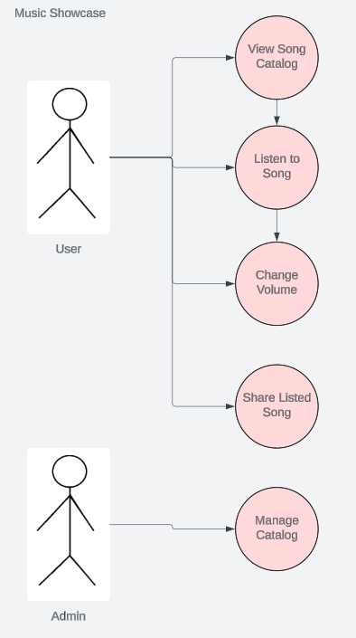

## Use Case 1-5 Diagram Narrative

The user must scroll down the home page to view the song catalog. The user can then hit play to hear the first music option on the track. The user can also change the volume of the music that is playing with a volume slider. If the user likes the song, they can click the share button which will allow them to post it on their social media to share it with other people. An administrator’s job is to update the song catalog by adding, replacing, or removing songs from the catalog.

## Use Case 6-7 Diagram Program/Workshop Info Management Group

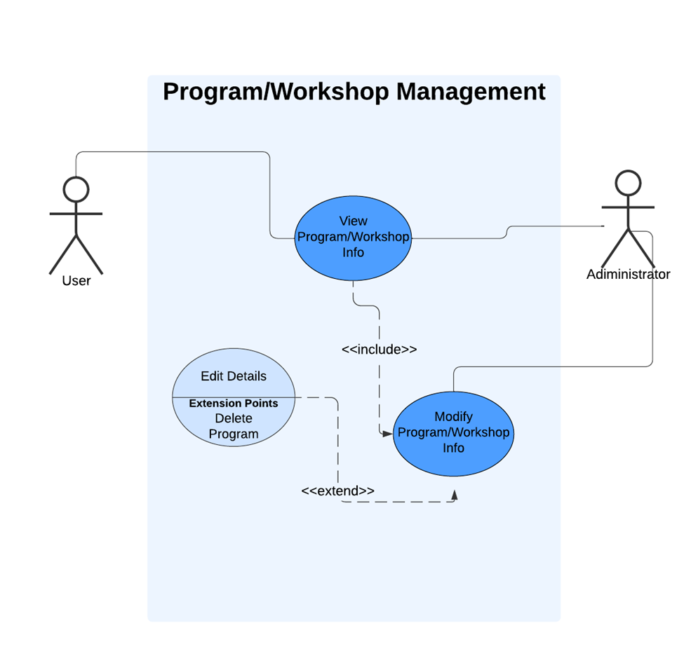

## Use Case 6-7 Diagram Narrative

The Program/Workshop Management system provides users with the ability to view information about various programs and workshops, enabling them to stay informed about available options. Administrators have enhanced access, allowing them not only to view but also to modify program and workshop details, ensuring that information remains accurate and up to date. Through an extension point labeled "Edit Details," administrators can make specific changes, such as updating or reordering content, while also having the option to delete programs when necessary. This setup distinguishes user and administrator roles, providing users with straightforward access to information while empowering administrators to manage and maintain program data efficiently.

## Use Case 8-9 Diagram Contact Form Group

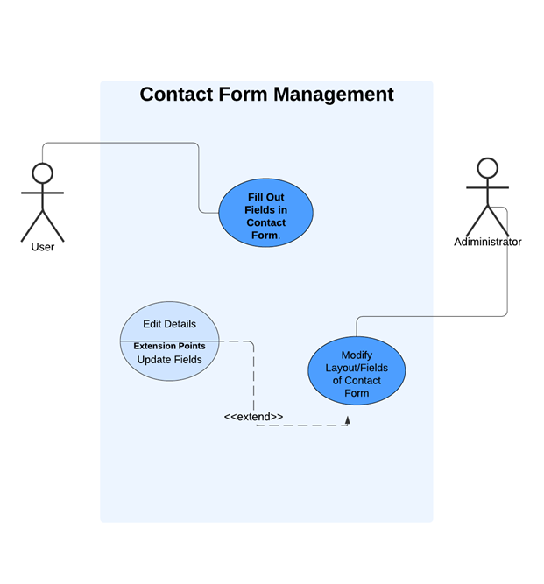

## Use Case 8-9 Diagram Narrative

The Contact Form Management system allows users to fill out fields in the contact form, enabling them to communicate with the organization. Administrators have additional access to modify the form's layout and fields, ensuring it aligns with organizational needs. Through an extension point labeled Update Fields, administrators can make detailed adjustments, like editing or reordering fields, keeping the form adaptable and relevant. This setup highlights the difference in user and administrator permissions, ensuring both accessibility for users and flexibility for administrators in managing contact form details.

## Use Case 10-11 Contact Form

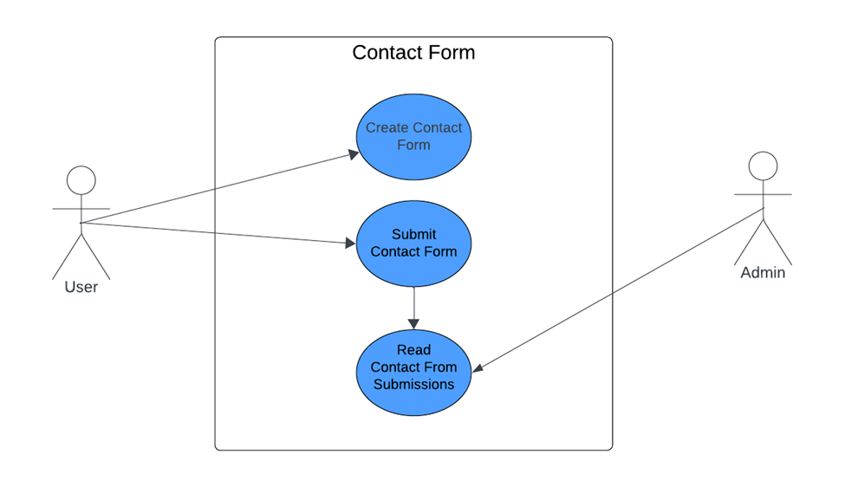Use Case 10-11 Contact Form Narrative

The contact form system allows users to create and submit forms, which administrators can review later. First, the user fills out the contact form by entering details like their name, email, and message. Then, they submit the form, which is checked for errors and saved in the database. Administrators can log in to the system to read and manage these submissions. The ability to read submissions depends on the forms being successfully submitted. Submitting forms is low risk but reviewing them can be higher risk since it might involve sensitive information. This system helps users and administrators communicate efficiently.

## Use Case 12-16 Diagram Donation Process

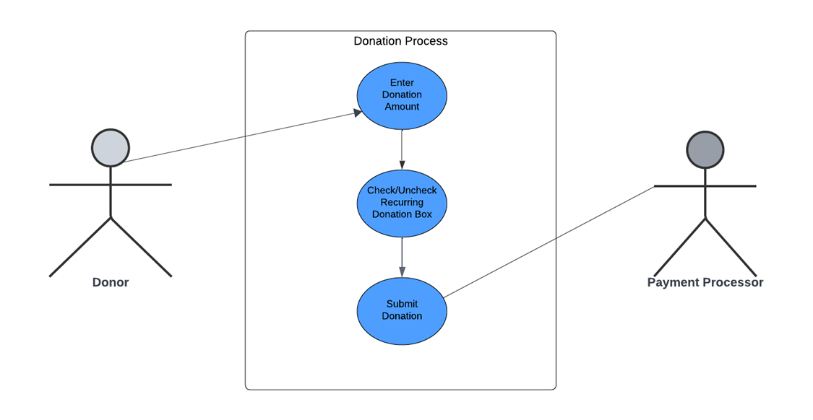

## Use Case 12-16 Diagram Narrative

This use case diagram shows how the donor interacts with the donation system. The donor can make a donation by selecting an amount, deciding whether the donation is one-time or recurring, and choosing a payment method (PayPal or credit card). The system then checks the details and processes the payment securely. The diagram illustrates the steps the donor goes through and how the system handles the donation process, ensuring everything works smoothly and securely. It helps explain the overall flow of the donation process without showing any behind-the-scenes management functions.

## Use Case 17-18 Diagram Review System

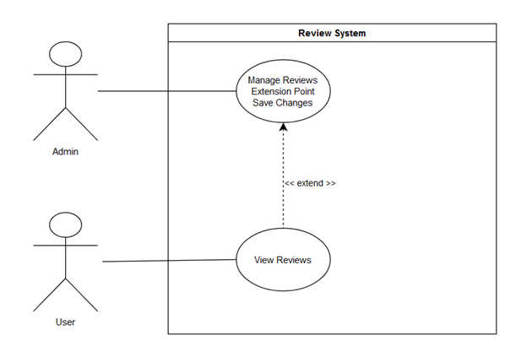

## Use Case 17-18 Diagram Narrative

The admin makes changes to the displayed reviews on the website from the Wix backend. The user viewing the updated reviews depends on the admin clicking the save button for the changes.

## Use Case 19-20 Diagram Social Media Integration System

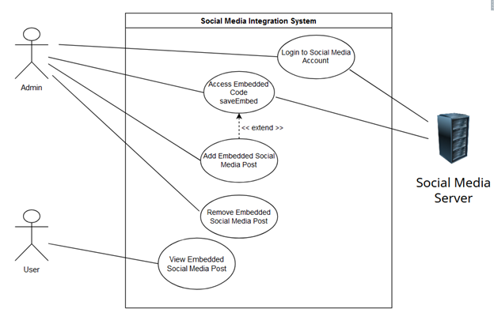

## Use Case 19-20 Diagram Narrative

The admin logs into the Social media account which requires a connection to the social media server. The admin then selects the desired social media post, clicks the share button, and accesses the embed code. The admin then uses this code in the Wix backend and pastes the code to add the desired social media post. Removing the social media post or having a user view an embedded post does not require the actor to connect the social media server.

## 

## Use Case 21-22 Diagram Sponsors Showcase

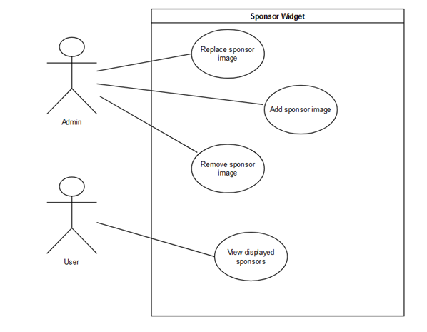

## Use Case 21-22 Diagram Narrative

The administrator can maintain the sponsor widget by either removing, adding, or replacing a sponsor’s image in the widget. The one-use case for a user is viewing the displayed sponsors that the administrator displayed.

## Use Case 23-24 Diagram Mission Statement

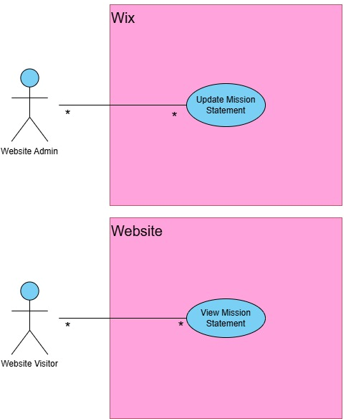

## Use Case 23-24 Diagram Narrative

The visitor is able to navigate to the Mission Statement via the “About” tab. This mission statement is the result of whatever the website admin inserts on the CMS side, which in this case is Wix. The mission statement is reflective of what the website puts in Wix at any given time.

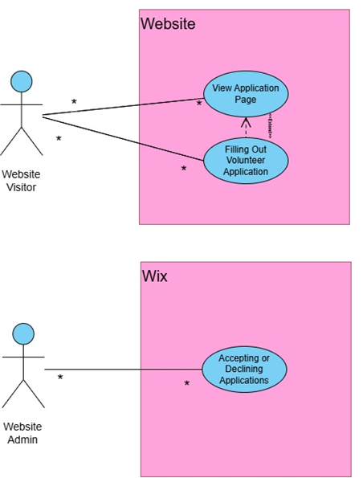Use Case 25-27 Diagram

## Use Case 25-27 Diagram Narrative

Visitors who express interest in volunteering for events can access the sign-up form via the “Get Involved” page. By clicking on the volunteer button, the visitor is taken to the application, which they will fill out with all the necessary information. When they have filled it out, they then hit submit, where the website admin will receive it. These responses will be viewable from the CMS, and the admin will be able to either discard the application or follow up with the applicant via a method of communication provided.

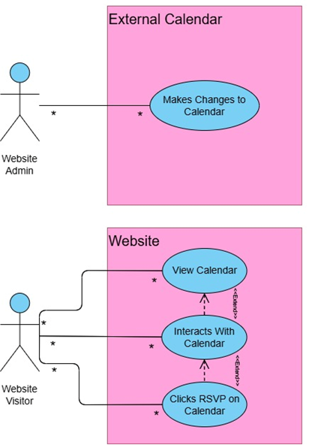Use Case 28-31 Diagram

## Use Case 28-31 Diagram Narrative

The visitor is able to view the calendar via the “Get Involved” page as well. All calendar updates are made within the website admin’s calendar of choice. After changing, adding, or deleting an event, it will show up on the website. From there, visitors can interact with events by clicking on them to have information tabs pop out. Inside these tabs will be all the relevant information for the event, as well as an RSVP button. Clicking this button will allow visitors to submit information, and have their name added to a list of participants that is visible to the admin.

## Use Case 32 & 34 Diagram Website Interface:

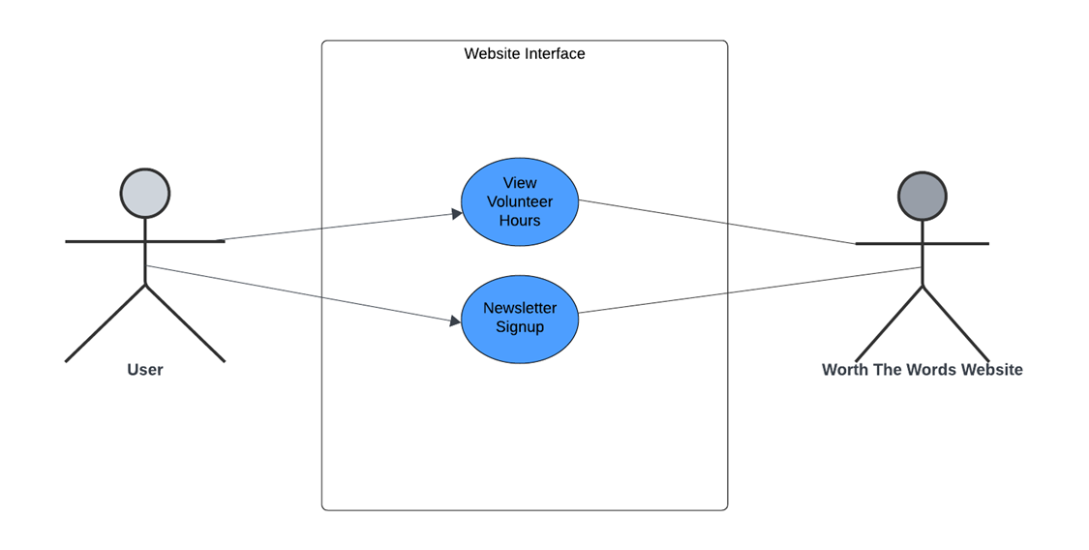Use Case 32 & 34 Diagram Narrative

In this use case diagram, the User interacts with the Worth the Words Website to perform two main functions: View Volunteer Hours and Newsletter Signup Button. When viewing volunteer hours, the User initiates an action to access their recorded hours contributed to the organization. The website system retrieves this data from the database and displays it, allowing the User to view their contributions. For the newsletter signup, the User clicks on the signup button, inputs their email, and submits it to subscribe to the organization's newsletter. The website system validates the email format and, upon successful validation, stores it in the database for future communications.

## Use Case 33 Diagram Update Volunteer Hours

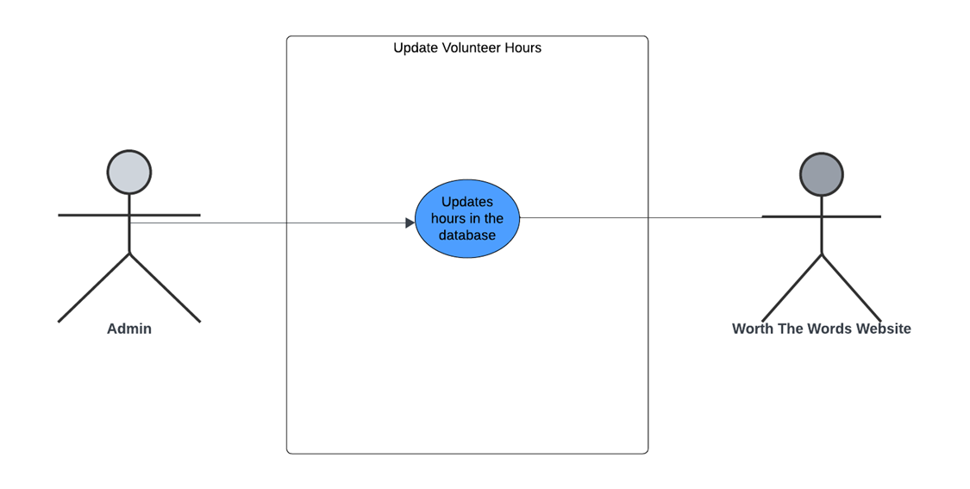Use Case 33 Diagram Narrative

In this use case, the Admin interacts with the Worth the Words Website to Update Volunteer Hours. This interaction allows the Admin to input, modify, or correct the recorded hours contributed by volunteers, ensuring accurate and up-to-date records.

# Trace Matrix

* [**Trace Matrix Excel Sheet**](https://cardmaillouisville-my.sharepoint.com/:x:/g/personal/alstri02_louisville_edu/EfX6JeEe1ElGkNao6RGy220BSNmd0InLjciUv5RMF5FT6A?e=EXGYBr)

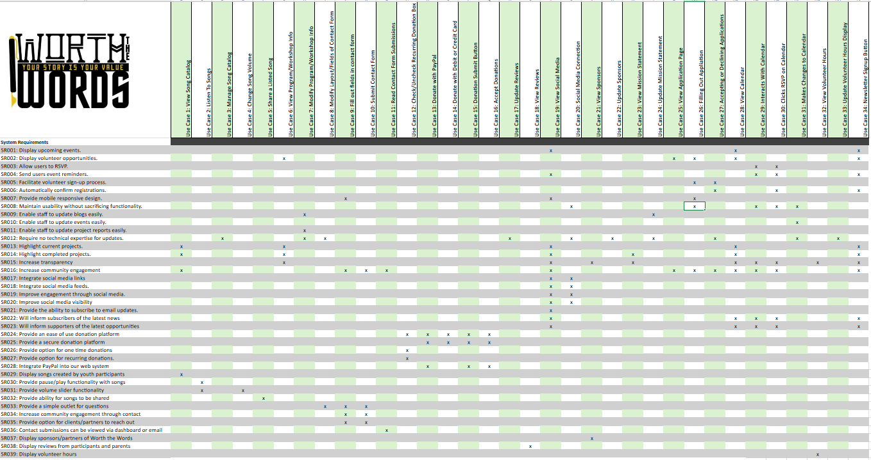

## Trace Matrix Narrative

Our trace matrix serves the purpose of matching our use cases with the requirements that each one fulfills. We have system requirements on the left-hand side each with a unique identifier (SR0##) and use cases on the top that also have unique identifiers (Use Case #). Due to certain use cases fulfilling multiple requirements, we have use cases that fulfill similar requirements of others. Some examples include viewing social media, joining the newsletter, and interacting with the calendar use cases fulfilling the system requirement of increasing community engagement. Our system requirements and use cases were designed with the primary purpose of developing a system that is focused on improving end user experience, building engagement, and increasing monetary funding. If scope creep were to occur, system requirements and use cases are easily added, removed, or updated in the excel sheet that the trace matrix is stored in.

# Use Case Descriptions:

### Use Case 1: User Views Song Catalog

|  |  |  |
| --- | --- | --- |
| **Use Case Name**: User Views Song Catalog | **ID**: 1 | **Importance Level**: Low |
| **Primary Actor**: User | | **Use Case Type**: Overview, Essential |
| **Stakeholders and Interests**:   * **User:** Wants to view songs in the catalog to see. * **Administrator:** Wants to ensure that users can see examples of work from previous students. | | |
| **Brief Description**: The user will view songs via an integrated player. | | |
| **Trigger**: User scrolls on the home page  **Type**: External | | |
| **Relationships**:  Association: User  Include:  Extend: Use Case: 2,3,4,5  Generalization: | | |
| **Normal Flow of Events:**     1. The user loads onto the Worth the Words home page. 2. The user scrolls down to the bottom of the home page to view songs. 3. The user clicks the play button. 4. The user clicks and drags to set the desired volume. 5. The user clicks to play the next song. | | |
| **SubFlows:**  S-1: Scrolling through the song list   1. The user clicks the title of the next song. 2. The user clicks the right arrow. 3. The user clicks the left arrow. | | |
| **Alternate/Exceptional Flows:** | | |

### Use Case 2: User Listen To Songs

|  |  |  |
| --- | --- | --- |
| **Use Case Name**: User Listen To Songs | **ID**: 2 | **Importance Level**: Low |
| **Primary Actor**: User | | **Use Case Type**: Detail, Real |
| **Stakeholders and Interests**:   * **User:** Wants to listen songs in the catalog. * **Administrator:** Wants to ensure that users can hear examples of work from previous students. | | |
| **Brief Description**: The user will be able to listen to songs from previous students. | | |
| **Trigger**: User clicks the play button  **Type**: External | | |
| **Relationships**:  Association: User  Include:  Extend: Use Case 5 and 2  Generalization: | | |
| **Normal Flow of Events:**     1. The user loads onto the Worth the Words home page. 2. The user scrolls down to the bottom of the home page to view songs. 3. The user clicks the play button. 4. The user clicks and drags to set the desired volume. 5. The user clicks to play the next song. | | |
| **SubFlows:**  S-1: Playing the next song   1. The user clicks the title of the next song. 2. The user clicks the right arrow. 3. The user clicks the left arrow.   S-2: Changing the volume   1. The user clicks the drags on the volume slider. | | |
| **Alternate/Exceptional Flows:** | | |

### Use Case 3: Manage Song Catalog

|  |  |  |
| --- | --- | --- |
| **Use Case Name**: Manage Song Catalog | **ID**: 3 | **Importance Level**: Medium |
| **Primary Actor**: Administrator | | **Use Case Type**: Detail, Real |
| **Stakeholders and Interests**:   * **User:** Wants updated songs on the catalog. * **Administrator:** Wants to ensure that users can hear examples of up-to-date songs from previous students. | | |
| **Brief Description**: The Administrator will be able to update the song catalog. | | |
| **Trigger**: The administrator accesses the midi player.  **Type**: External | | |
| **Relationships**:  Association: Administrator  Include:  Extend:  Generalization: | | |
| **Normal Flow of Events:**     1. The administrator logs onto the Worth the Words home page. 2. The administrator scrolls to the song catalog. 3. The administrator clicks to add or remove songs. 4. The administrator removes any songs they choose. 5. The administrator adds any new songs. | | |
| **SubFlows:** | | |
| **Alternate/Exceptional Flows:** | | |

### Use Case 4: Change Song Volume

|  |  |  |
| --- | --- | --- |
| **Use Case Name**: Change Song Volume | **ID**: 4 | **Importance Level**: Low |
| **Primary Actor**: User | | **Use Case Type**: Detail, Real |
| **Stakeholders and Interests**:   * **User:** Wants to change the volume of the current song playing. | | |
| **Brief Description**: The user will be able to change the volume of the music player. | | |
| **Trigger**: The user clicks and drags the volume slider.  **Type**: External | | |
| **Relationships**:  Association: User  Include: Use Case 1  Extend:  Generalization: | | |
| **Normal Flow of Events:**     1. The user loads onto the Worth the Words home page. 2. The user scrolls down to the bottom of the home page to view songs. 3. The user clicks the play button. 4. The user clicks and drags to set the desired volume. 5. The user clicks to play the next song. | | |
| **SubFlows:** | | |
| **Alternate/Exceptional Flows:** | | |

### Use Case 5: Share a Listed Song

|  |  |  |
| --- | --- | --- |
| **Use Case Name**: Share a Listed Song | **ID**: 5 | **Importance Level**: Low |
| **Primary Actor**: User | | **Use Case Type**: Detail, Real |
| **Stakeholders and Interests**:   * **User:** Wants to share a song from the site. * **Administrator:** Wants to advertise the site to more users. * **Potential User:** Wants to see and be informed of the work from Worth the Words. | | |
| **Brief Description**: The user will be able share songs from the song catalog. | | |
| **Trigger**: The user clicks and drags the volume slider.  **Type**: External | | |
| **Relationships**:  Association: User  Include: Use Case 1  Extend:  Generalization: | | |
| **Normal Flow of Events:**     1. The user loads onto the Worth the Words home page. 2. The user scrolls down to the bottom of the home page to view songs. 3. The user clicks the play button. 4. The user clicks and drags to set the desired volume. 5. The user clicks to play the next song. | | |
| **SubFlows:** | | |
| **Alternate/Exceptional Flows:** | | |

### Use Case 6 View Program/Workshop Info:

|  |  |  |
| --- | --- | --- |
| **Use Case Name**: View Program/Workshop Info | **ID**: 6 | **Importance Level**: Medium |
| **Primary Actor**: User | | **Use Case Type**: Real |
| **Stakeholders and Interests**:     * ***User:*** Seeks clear, detailed information about programs or workshops. * ***Administrator:*** Needs a user-friendly display of accurate, accessible program/workshop details to drive engagement. | | |
| **Brief Description**: This use case describes how a user can view detailed information for programs or workshops offered by Worth The Words. | | |
| **Trigger**: User clicks on a specific program or workshop title from the listing page.  **Type**: External | | |
| **Relationships**:  *Association:* User, Program  *Include:* None  *Extend:* Search Program  *Generalization:* Information System | | |
| **Normal Flow of Events:**   1. User logs into the portal. 2. User selects a specific program or workshop to view. 3. System retrieves detailed information for the selected program/workshop. 4. System displays details, including name, date, location, description, and any multimedia. | | |
| **SubFlows: View Additional Resources**  S-1: View Additional Resources   1. User clicks on additional resources (e.g., images, videos). 2. System opens a new section or modal with the additional media and resources for the program/workshop. | | |
| **Alternate/Exceptional Flows:**    **A-1**: If program information is unavailable, display an error message with a suggestion to contact support. | | |

### Use Case 7 Modify Program/Workshop Info:

|  |  |  |
| --- | --- | --- |
| **Use Case Name**: Modify Program/Workshop Info | **ID**: 7 | **Importance Level**: High |
| **Primary Actor**: Administrator | | **Use Case Type**: Real |
| **Stakeholders and Interests**:   * ***User:*** Rely on accurate program/workshop details to plan for attendance and participation. * ***Administrator:*** Needs to be able to edit, update, or delete program/workshop details to keep information current and accurate. | | |
| **Brief Description**: This use case allows the **Administrator** to update information on existing programs or workshops. This may include modifying titles, descriptions, dates, locations, or other details to keep content accurate and informative for potential participants. | | |
| **Trigger**: The Administrator selects the option to modify details for a specific program or workshop in the system.  **Type**: Internal | | |
| **Relationships**:  *Association: Administrator*  *Include: None*  *Extend: None*  *Generalization:* None | | |
| **Normal Flow of Events:**   1. The **Administrator** logs into the system. 2. The **Administrator** navigates to the **Program/Workshop Management** section. 3. The **System** displays a list of current programs and workshops. 4. The **Administrator** selects the specific program or workshop they wish to modify. 5. The **System** retrieves and displays the existing details of the selected program/workshop. 6. The **Administrator** edits the necessary fields (e.g., title, description, date, location). 7. The **Administrator** saves the changes. 8. The **System** updates the information and confirms that the modifications were successful. | | |
| **SubFlows: View Additional Resources**  S-1: View Additional Resources   1. **Administrator** selects a field to edit (e.g., title, description). 2. **Administrator** inputs the new information. 3. **System** validates the input and updates the field. | | |
| **Alternate/Exceptional Flows:**    **A-1**: Cancel Modifications  At any point during modification, the Administrator can cancel changes. The System reverts to the original details without saving modifications.  **Postconditions**  The program or workshop details are updated and visible to users if saved successfully.  If changes are canceled, the original details remain unchanged. | | |

### Use Case 8 Modify Layout / Fields of Contact Form

|  |  |  |
| --- | --- | --- |
| **Use Case Name**: Modify Layout/Fields of Contact Form | **ID**: 8 | **Importance Level**: Medium |
| **Primary Actor**: Administrator | | **Use Case Type**: Real, Overview |
| **Stakeholders and Interests**:     * ***User:*** Benefit from a clear, well-structured contact form that collects only necessary information and is easy to complete. * ***Administrator:*** Needs to be able to customize the contact form layout and fields to collect relevant information effectively. | | |
| **Brief Description**: This use case allows the **Administrator** to update information on existing programs or workshops. This may include modifying titles, descriptions, dates, locations, or other details to keep content accurate and informative for potential participants. | | |
| **Trigger**: The Administrator selects the option to modify details for a specific program or workshop in the system.  **Type**: Internal | | |
| **Relationships**:  *Association: Administrator*  *Include: None*  *Extend: None*  *Generalization:* None | | |
| **Normal Flow of Events:**   1. The **Administrator** logs into the system. 2. The **Administrator** navigates to the **Contact** **Form** **Management** section. 3. The **System** displays the current layout and field options for the contact form. 4. The **Administrator** selects the option to edit the layout or add/remove fields. 5. The **Administrator** modifies the layout or adds, removes, or edits fields as needed (e.g., name, email, message). 6. The **System** validates changes to ensure required fields are included. 7. The **Administrator** saves the modifications. 8. The **System** updates the contact form layout and fields, displaying a confirmation of successful changes. | | |
| **SubFlows: View Additional Resources**  S-1: Add New Field   1. The Administrator selects “Add Field.” 2. The System provides field options (e.g., text field, dropdown). 3. The Administrator configures the field name and type. 4. The System saves the new field to the form.   S-2: Remove Field   1. The Administrator selects an existing field to remove. 2. The System confirms that removing this field won’t disrupt required data collection. 3. The Administrator confirms removal, and the System deletes the field. | | |
| **Alternate/Exceptional Flows:**    **A-1**: Cancel Modifications  At any time during modification, the **Administrator** can cancel changes. The **System** will revert to the original layout and fields without saving any changes.  **Postconditions**  The contact form layout and fields are updated to reflect the changes made by the **Administrator**.  If changes are canceled, the contact form retains its original layout and fields. | | |

### Use Case 9 Fill Out Fields in Contact Form:

|  |  |  |
| --- | --- | --- |
| **Use Case Name**: Fill Out Fields in Contact Form | **ID**: 9 | **Importance Level**: Medium |
| **Primary Actor**: User | | **Use Case Type**: Real |
| **Stakeholders and Interests**:     * ***User:*** Needs a straightforward and efficient way to contact the organization by filling out the form with relevant information. * ***Administrator:*** Benefits from receiving clear and complete information from users for follow-up and engagement. | | |
| **Brief Description**: This use case allows the **User** to fill out the contact form on the website, providing the necessary details to connect with the organization. The form should be easy to complete, with fields that are intuitive and relevant. | | |
| **Trigger**: The **User** selects the option to access the contact form on the website.  **Type**: External | | |
| **Relationships**:  *Association: User*  *Include: None*  *Extend: None*  *Generalization:* None | | |
| **Normal Flow of Events:**   1. The User navigates to the Contact Us page. 2. The System displays the contact form, including fields for Name, Email, Subject, and Message. 3. The User fills out each required field with relevant information. 4. The User reviews the entered information for accuracy. 5. The User submits the form. 6. The System validates the information to ensure required fields are filled. 7. Upon successful validation, the System sends the form data to the Administrator and displays a confirmation message to the User. | | |
| **SubFlows: View Additional Resources**  S-1: Validate Required Fields   1. The System checks that all required fields are completed. 2. If any required fields are missing, the System prompts the User to fill them in. | | |
| **Alternate/Exceptional Flows:**    **A-1**: Missing Required Fields  If the User attempts to submit the form with incomplete information, the System displays an error message indicating which fields need to be filled out.  **Postconditions**  The contact form submission is complete, and the Administrator receives the information.  If the submission fails due to missing fields, the User is prompted to complete the form. | | |

### Use Case 10-11 Contact Form:

|  |  |  |
| --- | --- | --- |
| **Use Case Name**: Fill Out Fields in Contact Form | **ID**: 10-11 | **Importance Level**: High |
| **Primary Actor**: User, Admin | | **Use Case Type**: Real |
| **Stakeholders and Interests**:     * ***User:*** Needs a simple and efficient way to submit their inquiry or massage via the contract form * ***Administrator:*** Benefits from receiving organized and complete user information for timely follow-up and response | | |
| **Brief Description**: This use case allows the **User** to fill out the contact form on the website, providing the necessary details to connect with the organization. The form should be easy to complete, with fields that are intuitive and relevant. | | |
| **Trigger**: The **User** selects the option to access the contact form on the website.  **Type**: External | | |
| **Relationships**:  *Association: User, Admin*  *Include: None*  *Extend: None*  *Generalization:* None | | |
| **Normal Flow of Events:**   1. The User navigates to the Contact Us page. 2. The System displays the contact form, including fields for Name, Email, Subject, and Message. 3. The User fills out each required field with relevant information. 4. The User reviews the entered information for accuracy. 5. The User submits the form. 6. The System validates the information to ensure required fields are filled. 7. Upon successful validation, the System sends the form data to the Administrator and displays a confirmation message to the User. | | |
| **SubFlows: View Additional Resources**  S-1: Validate Required Fields   1. The System checks that all required fields are completed. 2. If any required fields are missing, the System prompts the User to fill them in. | | |
| **Alternate/Exceptional Flows:**    **A-1**: Missing Required Fields  If the User attempts to submit the form with incomplete information, the System displays an error message indicating which fields need to be filled out.  **Postconditions**  The contact form submission is complete, and the Administrator receives the information.  If the submission fails due to missing fields, the User is prompted to complete the form. | | |

### Use Case 12 Check/Uncheck Recurring Donation Box:

|  |  |  |
| --- | --- | --- |
| **Use Case Name**: Check/Uncheck Recurring Donation Box | **ID**: 12 | **Importance Level**: Moderate |
| **Primary Actor**: Website User (Donor) | | **Use Case Type**: Detail, Essential |
| **Website User (Donor):** A user who is interested in making a recurring donation to Worth the Words.  ***Website***: The system facilitating the donation process. | | |
| **Brief Description**: This use case describes how a donor selects or deselects the option to make a recurring donation when contributing through Worth the Words' website. | | |
| **Trigger**: The user decides to donate and is presented with the option to make the donation a recurring one.  **Type**: External | | |
| **Relationships**:  *Association:* The Website User interacts with the donation interface to check/uncheck the recurring donation option. | | |
| **Normal Flow of Events:**  The Website User navigates to the donation page.  The user fills out the necessary donation information (amount, payment method, etc.).  The user encounters the "Make this a recurring donation" checkbox.  The user selects or deselects the checkbox based on their preference.  The system registers the user’s choice.  The user proceeds with completing the donation process. | | |
| **Alternate/Exceptional Flows:**  If the user does not select the recurring donation option, the system defaults to a one-time donation. | | |

### Use Case 13 Donate with PayPal:

|  |  |  |
| --- | --- | --- |
| **Use Case Name**: Donate with PayPal | **ID**: 13 | **Importance Level**: High |
| **Primary Actor**: Website User (Donor) | | **Use Case Type**: Detail, Essential |
| **Stakeholders and Interests**:  • **Website User (Donor)**: A user who wants to make a donation using PayPal.  • **PayPal**: The payment gateway that facilitates secure donations.  • **Website**: The platform facilitating the donation process for Worth the Words. | | |
| **Brief Description**: This use case describes how a donor completes a donation transaction using PayPal on Worth the Words’ website. | | |
| **Trigger**: The user selects PayPal as their preferred payment method during the donation process.  **Type**: External | | |
| **Relationships**:  *Association:* The Website User interacts with the donation interface and PayPal system to complete the payment. | | |
| **Normal Flow of Events:**  The Website User navigates to the donation page.  The user selects an amount to donate and chooses PayPal as the payment method.  The system redirects the user to the PayPal login page.  The user logs into their PayPal account and confirms the payment.  PayPal processes the transaction and sends confirmation to both the user and Worth the Words.  The system redirects the user back to the website, displaying a confirmation message. | | |
| **Alternate/Exceptional Flows:**  If the user cancels the PayPal transaction, the system redirects the user back to the donation page. | | |

### Use Case 14 Donate with Debit or Credit Card:

|  |  |  |
| --- | --- | --- |
| **Use Case Name**: Donate with Debit or Credit Card | **ID**: 14 | **Importance Level**: High |
| **Primary Actor**: Website User (Donor) | | **Use Case Type**: Detail, Essential |
| **Stakeholders and Interests**:  **Website User (Donor):** A user who prefers to donate using a debit or credit card.  **Payment Processor**: The system facilitating secure card transactions.  **Website**: The platform facilitating the donation process for Worth the Words. | | |
| **Brief Description**: This use case describes how a donor completes a donation using a debit or credit card on Worth the Words’ website. | | |
| **Trigger**: The user selects the debit or credit card option as their payment method during the donation process.  **Type**: External | | |
| **Relationships**:  *Association:* The Website User interacts with the donation interface and the payment processor to complete the transaction. | | |
| **Normal Flow of Events:**  The Website User navigates to the donation page.  The user selects an amount to donate and chooses the debit or credit card payment option.  The system prompts the user to input their card details (e.g., card number, expiration date, CVV).  The user submits the card information, and the system verifies the details with the payment processor.  The payment processor approves the transaction, and the donation is processed.  The system provides a confirmation message to the user and sends a receipt via email. | | |
| **Alternate/Exceptional Flows:**  If the user cancels the payment, the system returns the user to the donation page without processing the transaction. | | |

### Use Case 15 Donate Submit Button:

|  |  |  |
| --- | --- | --- |
| **Use Case Name**: Donation Submit Button | **ID**: 15 | **Importance Level**: High |
| **Primary Actor**: Website User (Donor) | | **Use Case Type**: Detail, Essential |
| **Stakeholders and Interests**: A user completing their donation process by submitting their payment.  **Website**: The platform processing the donation. | | |
| **Brief Description**: This use case describes how a donor finalizes their donation by clicking the submit button after entering the required donation and payment details. | | |
| **Trigger**: The user finishes filling out their donation information and clicks the "Submit" button to process the payment.  **Type**: External | | |
| **Relationships**:  *Association:* The Website User interacts with the donation interface to submit their payment. | | |
| **Normal Flow of Events:**  The Website User completes all the required fields for the donation, including the donation amount and payment information.  The user clicks the "Submit" button to confirm the donation.  The system validates the donation details (amount, payment method, recurring option).  The system processes the donation through the selected payment method (PayPal, debit/credit card).  Once the payment is successfully processed, the system displays a confirmation message and sends a receipt via email. | | |
| **Alternate/Exceptional Flows:**  If there is an issue with the payment method (card declined or PayPal failure), the system notifies the user and prompts for an alternative payment. | | |

### Use Case 16 Accept Donations:

|  |  |  |
| --- | --- | --- |
| **Use Case Name**: Accept Donations | **ID**: 16 | **Importance Level**: High |
| **Primary Actor**: Website System | | **Use Case Type**: Detail, Essential |
| **Stakeholders and Interests**:  **Website User (Donor):** A user who expects their donation to be processed securely.  **Website System:** The platform responsible for processing donations and ensuring their secure and successful handling. | | |
| **Brief Description**: This use case describes how the website system processes and accepts donations made by donors on the Worth the Words platform. | | |
| **Trigger**: A donation is initiated when a user submits the donation information and payment details.  **Type**: External | | |
| **Relationships**:  *Association:* The Website System interacts with external payment processors (e.g., PayPal, credit card networks) to accept donations. | | |
| **Normal Flow of Events:**  The Website System receives the donor’s payment information from the Submit Donation action.  The system validates the donation amount and ensures all required fields are complete.  The system communicates with the selected payment processor (PayPal, credit card) to initiate the transaction.  The payment processor validates the transaction and responds to the website system.  If the payment is approved, the website system confirms the donation and records the transaction in the database.  The system sends a confirmation receipt to the donor via email and displays a success message on the website.  The donation amount is transferred to Worth the Words' account. | | |
| **Alternate/Exceptional Flows:**  If there is an issue with the payment method (card declined or PayPal failure), the system notifies the user and prompts for an alternative payment. | | |

### Use Case 17: Change Reviews

|  |  |  |
| --- | --- | --- |
| **Use Case Name**: Change Reviews | **ID**: 17 | **Importance Level**: High |
| **Primary Actor**: Admin | | **Use Case Type**: Overview, Real |
| **Stakeholders and Interests**:   * ***Administrator:*** Needs to manage/change the displayed reviews * ***User:*** The reviews are made for the user to view | | |
| **Brief Description**: This use case describes how a web admin can manage and change the reviews/testimonies displayed | | |
| **Trigger**: Admin logs into Wix, visits backend of home page, and scrolls down to the reviews section.  **Type**: Internal | | |
| **Relationships**:  *Association:* User  *Include:*  *Extend:*  *Generalization:* Reviews System | | |
| **Normal Flow of Events:**   1. The admin logs into Wix backend 2. Admin visits content management section 3. Admin goes to homepage management section 4. The admin scrolls down to reviews section in homepage. 5. Admin manages a Review   If the admin edits the image, S1 subflow is performed  If the admin edits the star rating of the review, S2 subflow is performed  If the admin edits the text of the review, S3 subflow is performed   1. Admin click the save button to save changes to the system | | |
| **SubFlows:**  S-1: Change/Remove/Add Image of Reviewer   1. The Admin clicks on the reviewer’s image. 2. The admin deletes, changes, or adds in an image.   S-2: Change the Star Rating   1. The Admin clicks the star rating. 2. Admin changes the star rating from 1-5.   S-3: Changes the text in the review   1. The Admin clicks the textbook in the review 2. Admin edits the text in the text box. | | |
| **Alternate/Exceptional Flows:**     1. The Admin leaves the page before saving    1. The admin clicks the discard changes popup | | |

### Use Case 18: View Reviews

|  |  |  |
| --- | --- | --- |
| **Use Case Name**: View Reviews | **ID**: 18 | **Importance Level**: Low |
| **Primary Actor**: User | | **Use Case Type**: Overview, Real |
| **Stakeholders and Interests**:   * ***User:*** Views the displayed reviews * ***Administrator:*** Created the reviews that will be viewed by the user | | |
| **Brief Description**: This use case describes the path a user will take to view the reviews | | |
| **Trigger**: User visits the WorthTheWords home page and scrolls down to the reviews section.  **Type**: External | | |
| **Relationships**:  *Association:* User  *Include:*  *Extend: Display reviews*  *Generalization:* Reviews System | | |
| **Normal Flow of Events:**   1. The user visits the WorthTheWords website 2. The user scrolls down to the reviews section | | |
| **SubFlows:**   * *No specified subflows* | | |
| **Alternate/Exceptional Flows:**     1. The user visits Worth the Words’s contact page to leave provide a testimony/review 2. The user visits Worth the Word’s google reviews page to leave a testimony/review. | | |

### Use Case 19: View Social Media

|  |  |  |
| --- | --- | --- |
| **Use Case Name**: View Social Media | **ID**: 19 | **Importance Level**: Low |
| **Primary Actor**: User | | **Use Case Type**: Overview, Real |
| **Stakeholders and Interests**:   * ***User:*** Views the social media posts, for news and information * ***Administrator:*** Needs to manage/change the displayed reviews | | |
| **Brief Description**: This use case describes the process of a user viewing the social media posts via the Worth the Words website | | |
| **Trigger**: User visits the home page and scrolls down to the reviews section.  **Type**: External | | |
| **Relationships**:  *Association:* User  *Include:*  *Extend:*  *Generalization:* Social Media Integration | | |
| **Normal Flow of Events:**   1. User visits the WorthTheWords homepage 2. User scrolls down to the Social Media section 3. User views embedded posts | | |
| **SubFlows:**   * *No specified subflows* | | |
| **Alternate/Exceptional Flows:**     1. After viewing social media posts, user clicks on social media button on top of the website | | |

### Use Case 20: Social Media Connection

|  |  |  |
| --- | --- | --- |
| **Use Case Name**: Social Media Connection | **ID**: 20 | **Importance Level**: Low |
| **Primary Actor**: Admin | | **Use Case Type**: Detail, Real |
| **Stakeholders and Interests**:   * ***User:*** Views the displayed posts after the connection * ***Administrator:*** Created the embedded post for the user to view | | |
| **Brief Description**: Administrator connects a social media post to the website | | |
| **Trigger**: Admin logs into the Wix backend, visits content management section, creates social media embedded post  **Type**: Internal | | |
| **Relationships**:  *Association:* Admin  *Include:*  *Extend: Save Embedded Code*  *Generalization:* Social Media System | | |
| **Normal Flow of Events:**   1. Admin logs into social media page (Instagram example) 2. Admin selects a post to share 3. Admin clicks share button 4. Admin copies the embedded code option 5. Admin logs into the backend of the Wix CMS 6. Visits homepage section of the backend 7. Click add to see options for adding content to homepage 8. Click HTML code button under the “From the Web” sub header 9. Insert Embedded code from Social Media Post | | |
| **SubFlows:**   * *No specified subflows* | | |
| **Alternate/Exceptional Flows:**   * *No specified alternate/exceptional flows* | | |

### Use Case 21: View Sponsors

|  |  |  |
| --- | --- | --- |
| **Use Case Name**: View sponsors | **ID**: 21 | **Importance Level**: Low |
| **Primary Actor**: User | | **Use Case Type**: Overview, Essential |
| **Stakeholders and Interests**:   * ***User:*** Views the sponsors display * ***Administrator:*** Needs to display the correct sponsors for users | | |
| **Brief Description**: User views the organizations that are sponsoring or partnered with Worth the Words | | |
| **Trigger**: User visits the homepage then clicks about us button  **Type**: External | | |
| **Relationships**:  *Association:* User  *Include:*  *Extend:*  *Generalization:* Sponsors widget | | |
| **Normal Flow of Events:**   1. User visits the Worth the Words homepage 2. User clicks the about us button 3. User views sponsor display | | |
| **SubFlows:**   * *No specified subflows* | | |
| **Alternate/Exceptional Flows:**   * No specified alternate/exceptional flows | | |

### Use Case 22: Update Sponsor Display

|  |  |  |
| --- | --- | --- |
| **Use Case Name**: Update Sponsors | **ID**: 22 | **Importance Level**: Low |
| **Primary Actor**: Admin | | **Use Case Type**: Overview, Essential |
| **Stakeholders and Interests**:   * ***User:*** Views the displayed sponsors * ***Administrator:*** Creates the display and keeps it updated with current sponsors and partners | | |
| **Brief Description**: Administrator updates the display for current sponsors and partners | | |
| **Trigger**: Admin logs into the Wix backend system and visits the about us backend page  **Type**: Internal | | |
| **Relationships**:  *Association:* Admin  *Include:*  *Extend:*  *Generalization:* Sponsors widget | | |
| **Normal Flow of Events:**   1. Administrator logs into the Wix backend system 2. Administrator visits the about us backend page 3. Administrator clicks the image gallery for the sponsors 4. Administrator performs the update If the administrator removes an image, subflow 1 is performed If the administrator adds an image, subflow 2 is performed If the administrator replaces an image, subflow 3 is performed 5. Administrator saves changes | | |
| **SubFlows:**  S1: Admin removes an image   * Clicks remove button for image   S2: Administrator adds an image   * Clicks button to add image * Uploads image   S3: Administrator replaces an image   * Clicks on an image to update * Uploads image | | |
| **Alternate/Exceptional Flows:**   1. Administrator discards changes | | |

### Use Case 23: View Mission Statement

|  |  |  |
| --- | --- | --- |
| **Use Case Name**: View Mission Statement | **ID**: 23 | **Importance Level**: Low |
| **Primary Actor**: Website Visitor | | **Use Case Type**: Detail, Essential |
| **Stakeholders and Interests**:   * **Website Visitor**: wants to see what the nonprofit stands for, and aims to achieve * **Nonprofit team**: wants to make sure that visitors can clearly tell what their vision is and how they aim to accomplish it | | |
| **Brief Description**: This describes how a website visitor can navigate through the website in order to find and read the mission statement of the nonprofit. | | |
| **Trigger**: The visitor clicks on the “About” tab on the homepage  **Type**: External | | |
| **Relationships**:  Association: Visitor  Include:  Extend:  Generalization: | | |
| **Normal Flow of Events:**   1. The visitor sees the landing page of Worth the Words 2. The visitor clicks the “About” tab 3. The visitor is able to view the mission statement | | |
| **SubFlows:** | | |
| **Alternate/Exceptional Flows:** | | |

### Use Case 24: Update Mission Statement

|  |  |  |
| --- | --- | --- |
| **Use Case Name**: Update Mission Statement | **ID**: 24 | **Importance Level**: Low |
| **Primary Actor**: Website Admin | | **Use Case Type**: Detail, Essential |
| **Stakeholders and Interests**:   * **Website Admin**: Wants the mission statement to accurately display what the nonprofit is trying to achieve, even after possible shifts in focus or mission | | |
| **Brief Description:** This describes the process in which a website admin would change the HTML of the website in order to make the mission statement reflective of whatever they would like it to be. | | |
| **Trigger**: Website admin logging into the CMS and editing the About section, following a decision to update the mission statement.  **Type**: External | | |
| **Relationships**:  Association: Admin  Include:  Extend: Use Case 23: View Mission Statement  Generalization: | | |
| **Normal Flow of Events:**   1. The website admin logs into the CMS (Wix) 2. They then navigate to the portion of the website that is the “About” page 3. They edit the text that is displayed on the page under “Mission Statement” 4. They hit save on this change, and exit the CMS | | |
| **SubFlows:** | | |
| **Alternate/Exceptional Flows:**   1. After making a change to the Mission Statement they decide to revert it 2. They click on a different portion of the CMS 3. The CMS prompts them, asking if they want to save 4. They answer “No” or “Continue without saving” | | |

### Use Case 25: View Application Page

|  |  |  |
| --- | --- | --- |
| **Use Case Name**: View Application Page | **ID**: 25 | **Importance Level**: High |
| **Primary Actor**: Website Visitor | | **Use Case Type**: Detail, Essential |
| **Stakeholders and Interests**:   * **Website Admin**: Wants the visitor to be able to navigate to the application page to fill out their information | | |
| **Brief Description:** This describes the process in which a website visitor navigates from the landing page of the website to the application page. | | |
| **Trigger**: Website visitor navigates to the get involved page and clicks on the apply now button.  **Type**: External | | |
| **Relationships**:  Association: Visitor  Include:  Extend:  Generalization: | | |
| **Normal Flow of Events:**   1. The website visitor clicks on the ‘Get Involved’ tab on the landing page. 2. The website visitor clicks on the ‘Apply Now’ button within the ‘Get Involved’ page. 3. The website visitor can now view the application page and the details that they would need to provide. | | |
| **SubFlows:** | | |
| **Alternate/Exceptional Flows:** | | |

### Use Case 26: Filling Out Application

|  |  |  |
| --- | --- | --- |
| **Use Case Name**: Filling Out Volunteer Application | **ID**: 26 | **Importance Level**: High |
| **Primary Actor**: Website Visitor looking to volunteer | | **Use Case Type**: Detail, Essential |
| **Stakeholders and Interests**:   * **Website Visitor**: Wants to help our nonprofit by signing up to volunteer in whatever manner best fits them. * **Nonprofit**: Wants website visitors to be interested in helping out and have an easy time finding and completing the application. | | |
| **Brief Description**: This describes the process by which a website visitor will navigate to Volunteer Application and complete it. | | |
| **Trigger**: The website visitor clicks on the “Volunteer Now” button under the “Get Involved” tab.  **Type**: External | | |
| **Relationships**:  Association: Website Volunteer with intent to become a volunteer  Include:  Extend: Use Case 25: View Application Page  Generalization: | | |
| **Normal Flow of Events:**   1. Visitor arrives on the landing page. 2. They click on the get involved tab. 3. They click on the volunteer now button. 4. They are directed to the volunteer application. 5. They complete the application. 6. They hit submit now. 7. They are given a thank you message. 8. They are redirected back to the landing page. | | |
| **SubFlows:** | | |
| **Alternate/Exceptional Flows:**  5a. They decide against submitting the form.  5b. They click cancel instead of submit.  5c. They are given a confirmation prompt.  5d. They click either confirm to leave or cancel to resume.  5e. Skip to step 8. | | |

### Use Case 27: Reviews Applications

|  |  |  |
| --- | --- | --- |
| **Use Case Name**: Accepting or Declining Applications | **ID**: 27 | **Importance Level**: High |
| **Primary Actor**: Website Admin | | **Use Case Type**: Detail, Essential |
| **Stakeholders and Interests**:   * **Nonprofit:** Wants to be able to review and bring on help as they are able or as needed. * **Website Visitor:** Wants to have their application seen by nonprofit in order to convey interest in volunteering. | | |
| **Brief Description**: This describes the process by which a website admin will judge applications sent in via the Volunteer Application Form. | | |
| **Trigger**: The website admin logs into the CMS and is able to review applications.  **Type**: External | | |
| **Relationships**:  Association: Website Admin  Include:  Extend: Use Case 26: Filling Out Volunteer Form  Generalization: | | |
| **Normal Flow of Events:**   1. Website Admin logs into the CMS. 2. They will be able to open and review the submitted responses from interested.   2a. They hit remove application, effectively denying an application  OR  2b. They hit accept and are able to send the applicant a message via email or other provided contact method. | | |
| **SubFlows:** | | |
| **Alternate/Exceptional Flows:** | | |

### Use Case 28: View Calendar

|  |  |  |
| --- | --- | --- |
| **Use Case Name**: View Calendar | **ID**: 28 | **Importance Level**: High |
| **Primary Actor**: Website Visitor | | **Use Case Type**: Detail, Essential |
| **Stakeholders and Interests**:   * **Website Visitor**: Wants to view the upcoming events and related info. * **Nonprofit**: Wants visitors to be aware of upcoming events so that they can see info and sign up. | | |
| **Brief Description**: This describes the process by which a website visitor will navigate to the calendar and view upcoming events. | | |
| **Trigger**: Visitor clicks on the “Get Involved” tab.  **Type**: External | | |
| **Relationships**:  Association: Website Visitor.  Include:  Extend:  Generalization: | | |
| **Normal Flow of Events:**   1. Visitor arrives on the landing page. 2. They click the “Get Involved” tab. 3. They are able to view the calendar. | | |
| **SubFlows:** | | |
| **Alternate/Exceptional Flows:**  3a. They hit the toggle to switch between the standard calendar and filtered calendar. | | |

### Use Case 29: Interacts with Calendar

|  |  |  |
| --- | --- | --- |
| **Use Case Name**: Interacts with Calendar | **ID**: 29 | **Importance Level**: High |
| **Primary Actor**: Website Visitor | | **Use Case Type**: Detail, Essential |
| **Stakeholders and Interests**:   * **Website Visitor:** Wants to be able to view information pertaining to calendar events. * **Nonprofit:** Wants visitors to be able to be directed to the correct information pertaining to events. | | |
| **Brief Description**: This describes the process by which a website visitor will interact with the calendar to view events in which they are interested. | | |
| **Trigger**: Visitor clicks on an event that is displayed on the calendar.  **Type**: External | | |
| **Relationships**:  Association: Website Visitor  Include:  Extend: Use Case 28: View Calendar  Generalization: | | |
| **Normal Flow of Events:**   1. Visitor arrives on the landing page. 2. Visitor clicks on the “Get Involved” tab. 3. They view the calendar. 4. They click on a calendar event to see more information. 5. The event pops out a tab of information. 6. The map updates to show the location of the event. | | |
| **SubFlows:** | | |
| **Alternate/Exceptional Flows:**  5a. They click anywhere on the site to close the information tab. | | |

### Use Case 30: Clicks RSVP on Calendar

|  |  |  |
| --- | --- | --- |
| **Use Case Name**: Clicks RSVP on Calendar | **ID**: 30 | **Importance Level**: High |
| **Primary Actor**: Website Visitor | | **Use Case Type**: Detail, Essential |
| **Stakeholders and Interests**:   * **Website Visitor**: Wants to be able to show interest in attending an event listed on the calendar. * **Nonprofit**: Wants to see visitor engagement and interest in the events they list on the calendar. | | |
| **Brief Description**: This process describes the way that visitors will click on the RSVP button to confirm their interest in an event. | | |
| **Trigger**: Visitor hits the RSVP button listed on the expanded tab of a calendar event.  **Type**: External | | |
| **Relationships**:  Association: Website Visitor  Include:  Extend: Use Case 29: Interacts with Calendar  Generalization: | | |
| **Normal Flow of Events:**   1. Visitor arrives on the landing page. 2. Visitor clicks on the “Get Involved” tab. 3. They view the calendar. 4. They choose an event on the calendar and click it. 5. They view the information pop out tab. 6. They click the RSVP button on the information pop out tab. 7. They type in necessary information (Name, Email, Phone Number). 8. The information is added to a list of participants in the event information. | | |
| **SubFlows:** | | |
| **Alternate/Exceptional Flows:** | | |

### Use Case 31: Makes Changes to Calendar

|  |  |  |
| --- | --- | --- |
| **Use Case Name**: Makes Changes to the Calendar | **ID**: 31 | **Importance Level**: High |
| **Primary Actor**: Website Admin | | **Use Case Type**: Detail, Essential |
| **Stakeholders and Interests**:   * **Nonprofit:** Wants the website to reflect the most current information about what is occurring in the near future. * **Website Visitor:** Wants to see relevant information about events in the near future. | | |
| **Brief Description**: The process describes how a Website Admin will make changes to the integrated calendar to reflect upcoming events. | | |
| **Trigger**: The admin changes, adds, or deletes events in a separate Google or Outlook calendar.  **Type**: External | | |
| **Relationships**:  Association: Website Admin  Include:  Extend:  Generalization: | | |
| **Normal Flow of Events:**   1. The Website Admin logs into either their Google or Outlook calendar. 2. They then choose a date to change, add, or delete an event. 3. They perform the respective action. 4. This information updates and connects with the integrated Wix plugin. 5. The information is now shown on the calendar as a reflection of the Google or Outlook calendar. | | |
| **SubFlows:** | | |
| **Alternate/Exceptional Flows:** | | |

### Use Case 32: View Volunteer Hours

|  |  |  |
| --- | --- | --- |
| **Use Case Name**: View Volunteer Hours | **ID**: 32 | **Importance Level**: High |
| **Primary Actor**: Website Admin or Designated Volunteer | | **Use Case Type**: Detail, Essential |
| **Stakeholders and Interests**:   * Website Admin and Volunteer: Wants to make sure that hours have been correctly counted and attributed to the correct person after the completion of an event. | | |
| **Brief Description**: The process describes how a Website Admin or volunteer will view hours that have been accumulated by a specific individual. | | |
| **Trigger**: User clicks on the ‘View Application’ button located in the ‘Get Involved’ tab.  **Type**: External | | |
| **Relationships**:  Association: Website Admin, Volunteer  Include:  Extend:  Generalization: | | |
| **Normal Flow of Events:**   1. User clicks on the ‘Get Involved’ tab. 2. User clicks on the ‘Apply Now’ tab. 3. User clicks on the ‘View Application’ button 4. User can see their confirmed application, as well as relevant volunteer data, such as hours. | | |
| **SubFlows:** | | |
| **Alternate/Exceptional Flows:**  4a. If the user is an admin, they will be able to see all applications and choose which to view the relevant data of. | | |

### Use Case 33: Updates Volunteer Hours Display

|  |  |  |
| --- | --- | --- |
| **Use Case Name**: Updates Volunteer Hours Display | **ID**: 33 | **Importance Level**: High |
| **Primary Actor**: Website Admin | | **Use Case Type**: Detail, Essential |
| **Stakeholders and Interests**:   * **Volunteer:** They want to see updated hours as a reflection of the time they spent helping at an event. | | |
| **Brief Description**: The process describes how a Website Admin will make changes to the display hours of a certain volunteer. | | |
| **Trigger**: The admin changes, adds, or deletes hours in the application view.  **Type**: External | | |
| **Relationships**:  Association: Website Admin  Include:  Extend:  Generalization: | | |
| **Normal Flow of Events:**   1. The admin clicks on the ‘Get Involved’ tab in the backend. 2. The admin clicks on the ‘Apply now’ tab. 3. The admin clicks the application of the volunteer whose hours need updating. 4. The admin updates the hours as needed based on physical or digital tracking from the event | | |
| **SubFlows:** | | |
| **Alternate/Exceptional Flows:** | | |

### Use Case 34: Newsletter Signup Button

|  |  |  |
| --- | --- | --- |
| **Use Case Name**: Newsletter Signup Button | **ID**: 34 | **Importance Level**: High |
| **Primary Actor**: User | | **Use Case Type**: Detail, Real |
| **Stakeholders and Interests**:   * **Admin:** Wants increase user retention and reach * **Website Visitor:** Wants to stay updated on the latest news and events | | |
| **Brief Description**: The process describes how a website end user will join the newsletter list. | | |
| **Trigger**: User clicks the newsletter button  **Type**: External | | |
| **Relationships**:  Association: User  Include:  Extend:  Generalization: | | |
| **Normal Flow of Events:**  **1.** The user loads the front page of Worth the Word’s website 2. The user clicks the newsletter button on the front page 3. User enters credentials If the user enters their email as their credential, then subflow S1 is performed If the user enters their phone number as their credential, then subflow S2 is performed 4. User clicks submit button | | |
| **SubFlows:** S1**:** The user enters the email address **S2:** The user enters their phone number | | |
| **Alternate/Exceptional Flows:**  1: User’s credentials are flagged as spam in the Wix filter | | |

# Sequence Diagrams:

### Sequence Diagram #1-5 Music Showcase

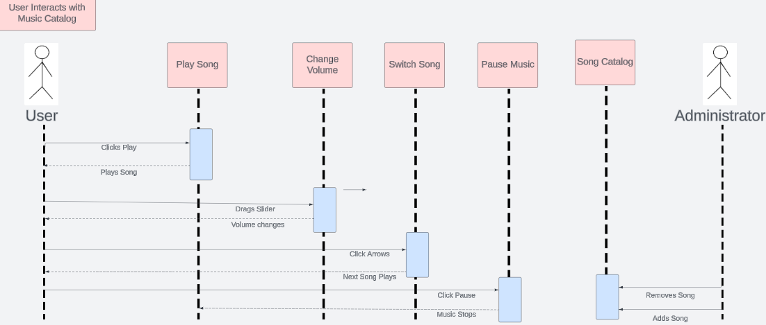

# Sequence Diagram #6-7 Modify Program/Workshop Info

### Sequence Diagram #8-9 Modify Layout/Fields of Contact Form

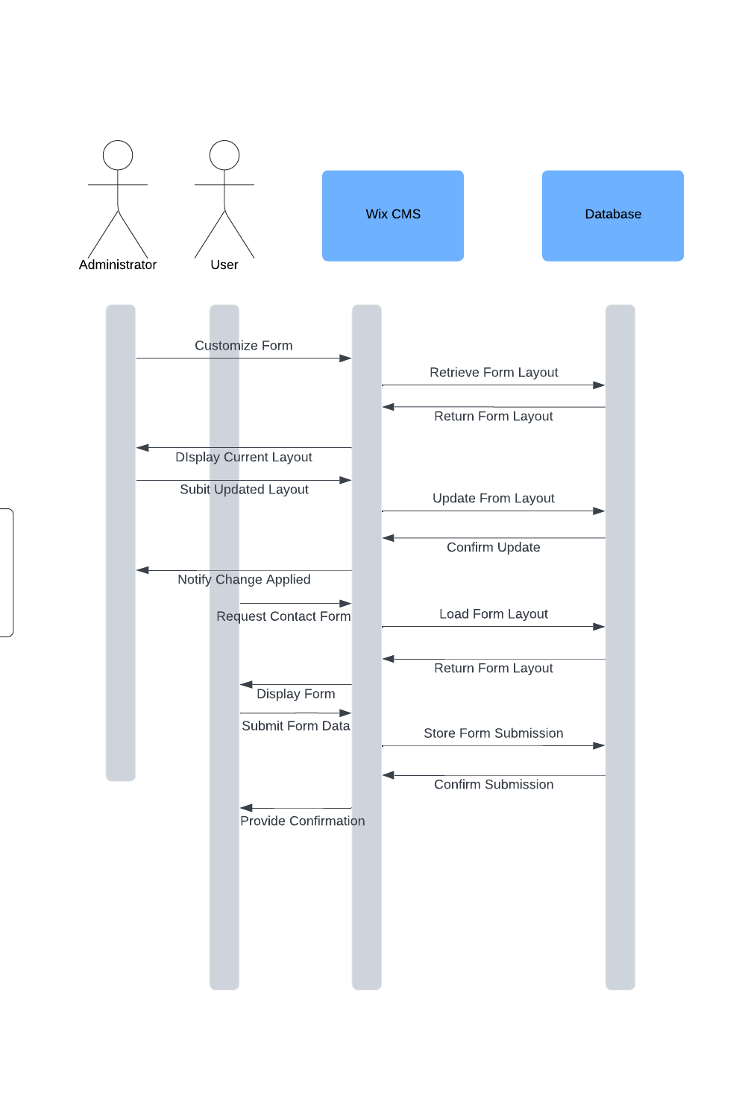

### Sequence Diagram #10-11

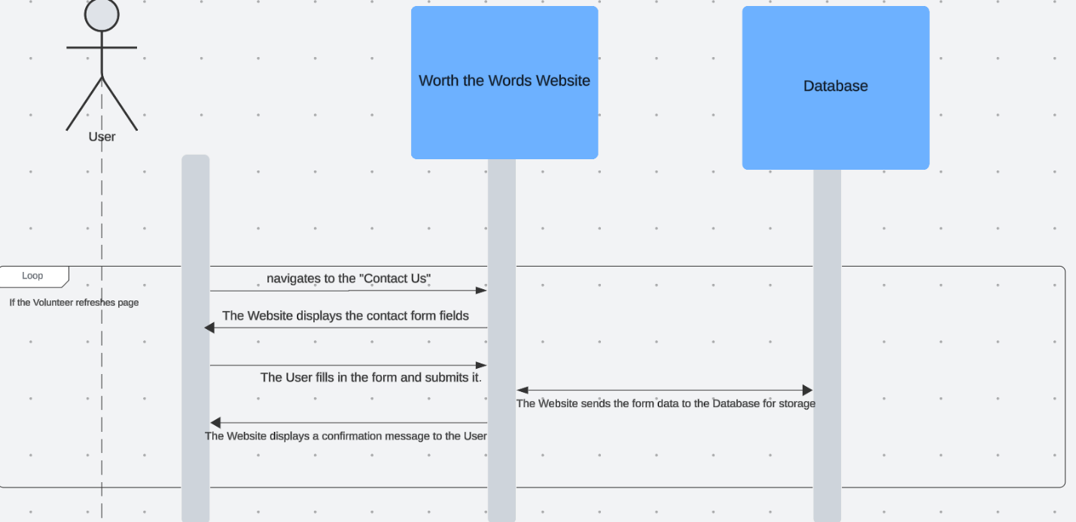

### Sequence Diagram #12-16 Donation System

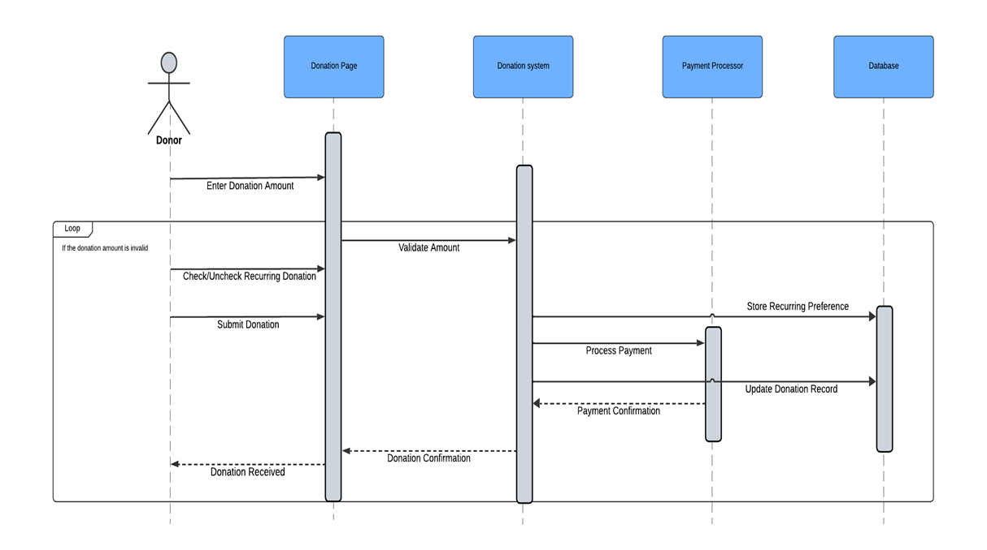

### #17-18 Reviews Sequence Diagram

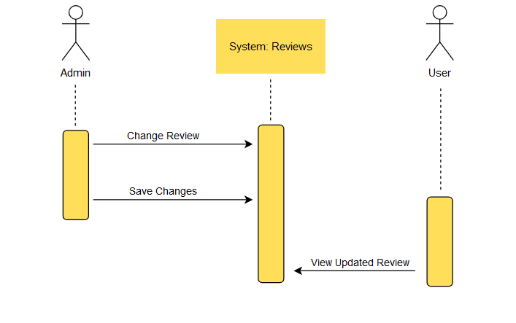

### #19-20 Social Media Sequence Diagram

### #21-22 Sponsors Sequence Diagram

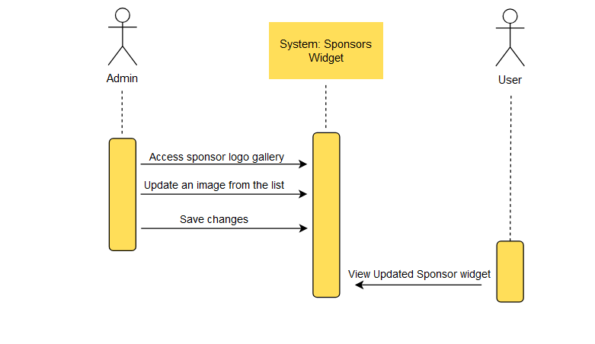

### #23-24 Mission Statement Sequence Diagram

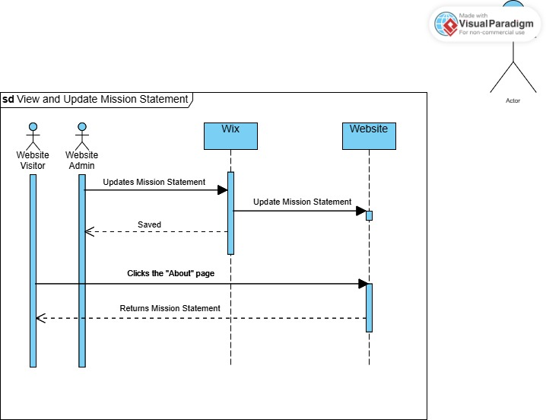

### #25-27 Application Sequence Diagram

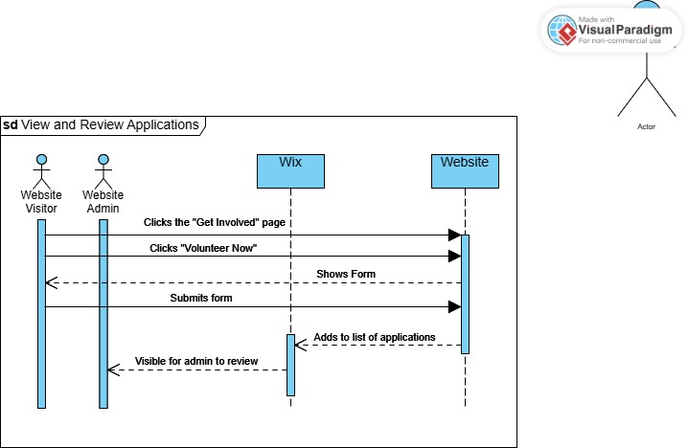

### #28-31 Calendar Sequence Diagram

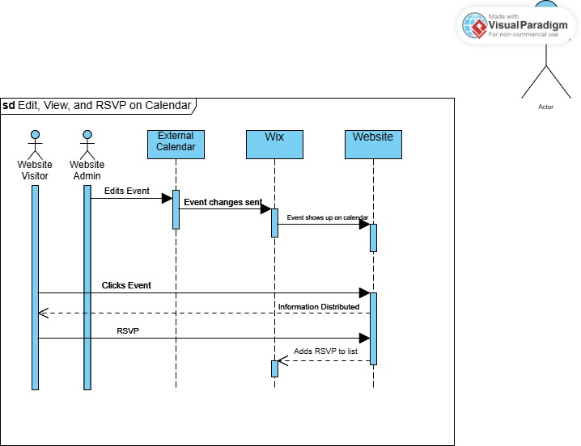

### Sequence Diagram #32-34

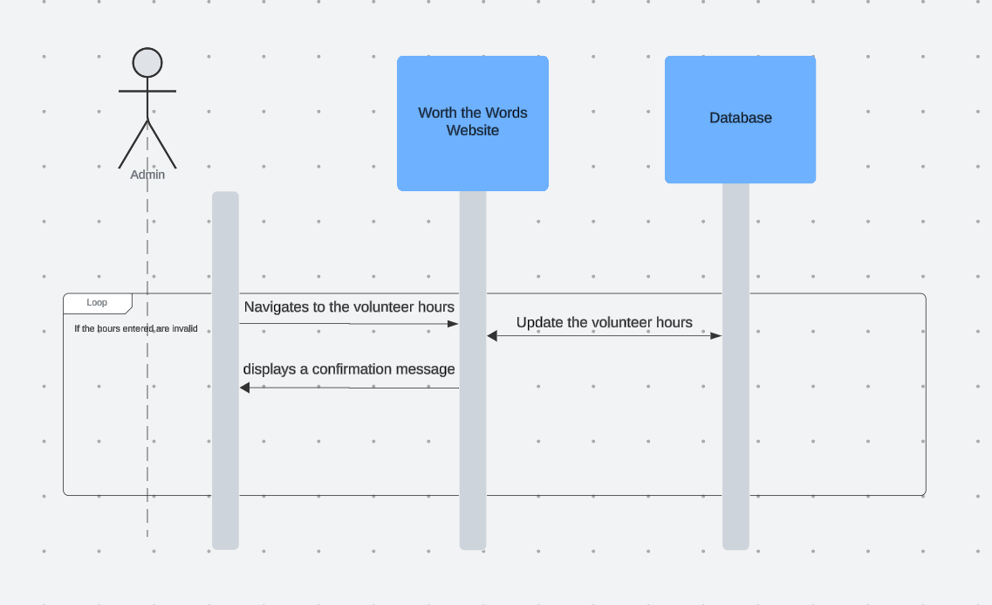Class Diagram:

## Class Diagram Model

## Class Diagram Narrative:

This class diagram outlines a dynamic system designed to handle multiple aspects of organizational operations, including user interactions, donations, events, and administrative tasks. At the center of the design are two key roles: Admin and User. The Admin class is responsible for overseeing essential organizational functions such as managing song catalogs, programs, contracts, donations, applications, and event logistics. On the other hand, the User class represents everyday participants who interact with the system by making donations, RSVP’ing for events, and subscribing to newsletters. The system includes a Donation class, which supports both one-time and recurring contributions, with user-specific records maintained through the User_Donation class. Events are organized via the Event class, which tracks details like dates, RSVPs, and updates. Administrative efficiency is further enhanced by modular components such as the Sponsors_Widget and Volunteer_Hours_Widget, which simplify managing sponsorships and volunteer hours. Additionally, the Song_Catalog and Program_Module classes allow for the management of multimedia content and program-related details, connecting administrators and users for seamless updates. To support communication and engagement, features like the Newsletter, MissionStatement, and Reviews_Module keep users informed and involved. At the same time, dedicated classes handle specialized tasks such as processing applications and managing contracts. The system is designed with a strong emphasis on modularity, hierarchy, and interconnectedness, creating an effective framework for both user engagement and internal processes.

# Database Design:

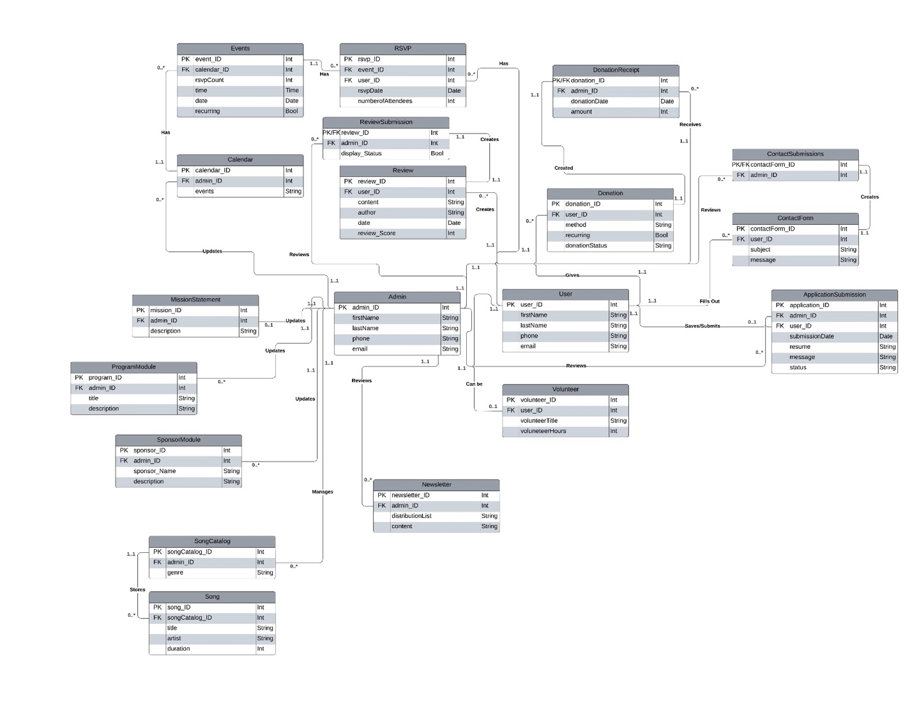

## Database Narrative

Our database is designed around the actions of the system admin and website users. Many of our design choices for our website make it so that the data design is fairly simple. The admin has the most relationships and does not require many bridges to map out the system. The admin_ID attribute is listed with several classes as a way to mark the author of certain changes, such as who changed the mission statement, or who added a sponsor to the carousel. Normalizing the submissions of reviews and donations are what required the most work. In these instances, we were able to separate classes into two distinct ones: one for the admin to review, and the other for the user to create or submit. We accomplished this by having the two classes share the same primary key, with the attributes depending on a combination of the primary key and foreign key from the user or admin. Our diagram branches off into the several options that users are given to go via the ribbon on the landing page. We ensured that classes were covered by following our To-Be model.

## Database Definitions:

**User**

|  |  |  |  |  |
| --- | --- | --- | --- | --- |
| Attribute | Definition | Type | Size | Key |
| user_ID | User’s unique identifier | int | 5 bytes | Primary |
| firstName | User’s first name | Str | 256 bytes | N/A |
| lastName | User’s last name | Str | 256 bytes | N/A |
| email | User’s email address | Str | 256 bytes | N/A |
| phone | User’s phone number | Str | 256 bytes | N/A |

**Admin**

|  |  |  |  |  |
| --- | --- | --- | --- | --- |
| Attribute | Definition | Type | Size | Key |
| admin_ID | Administrator’s unique identifier | Int | 5 bytes | Primary |
| firstName | Administrator’s first name | Str | 256 bytes | N/A |
| lastName | Administrator’s last name | Str | 256 bytes | N/A |
| email | Administrator’s email address | Str | 256 bytes | N/A |
| phone | Administrator’s phone number | Str | 256 bytes | N/A |

**Volunteer**

|  |  |  |  |  |
| --- | --- | --- | --- | --- |
| Attribute | Definition | Type | Size | Key |
| volunteer_ID | Volunteer unique identifier | Int | 5 bytes | Primary |
| user_ID | User ID | Int | 5 bytes | Foreign |
| volunteerTitle | Title for volunteer hours | Str | 256 bytes | N/A |
| volunteerHours | Number of volunteer hours | Int | 5 bytes | N/A |

**Newsletter**

|  |  |  |  |  |
| --- | --- | --- | --- | --- |
| Attribute | Definition | Type | Size | Key |
| newsletter_ID | Newsletter’s unique identifier | Int | 5 bytes | Primary |
| admin_ID | Administrator’s unique identifier | Int | 5 bytes | Foreign |
| distributionList | Distribution list of users | Str | 5 bytes | N/A |
| content | Contents of the newsletter | Str | 256 bytes | N/A |

**SongCatalog**

|  |  |  |  |  |
| --- | --- | --- | --- | --- |
| Attribute | Definition | Type | Size | Key |
| songCatalog_ID | Song Catalog’s unique identifier | int | 5 bytes | Primary |
| admin_ID | Administrator’s unique identifier | int | 5 bytes | Foreign |
| genre | Song genres | str | 256 bytes | N/A |

**Song**

|  |  |  |  |  |
| --- | --- | --- | --- | --- |
| Attribute | Definition | Type | Size | Key |
| songID | Song’s unique identifier | int | 5 bytes | Primary |
| songCatalog_ID | Song Catalog’s unique identifier | int | 5 bytes | Foreign |
| title | Song's title | str | 256 bytes | N/A |
| artist | Artist of song | str | 256 bytes | N/A |
| duration | Length of song | int | 5 bytes | N/A |

**SponsorModule**

|  |  |  |  |  |
| --- | --- | --- | --- | --- |
| Attribute | Definition | Type | Size | Key |
| sponsor_ID | Sponsor Module’s unique identifier | int | 5 bytes | Primary |
| admin_ID | Administrator’s unique identifier | int | 5 bytes | Foreign |
| sponsor_Name | Name of Sponsor | str | 256 bytes | N/A |
| description | Description of Song | str | 256 bytes | N/A |

**ProgramModule**

|  |  |  |  |  |
| --- | --- | --- | --- | --- |
| Attribute | Definition | Type | Size | Key |
| program_ID | Program Module’s unique identifier | int | 5 bytes | Primary |
| admin_ID | Administrator’s unique identifier | int | 5 bytes | Foreign |
| title | Title of Program | str | 256 bytes | N/A |
| description | Description of program | str | 256 bytes | N/A |

**MissionStatement**

|  |  |  |  |  |
| --- | --- | --- | --- | --- |
| Attribute | Definition | Type | Size | Key |
| mission_ID | Mission’s Statement’s unique identifier | int | 5 bytes | Primary |
| admin_ID | Administrator’s unique identifier | int | 5 bytes | Foreign |
| description | Description of Worth the Words’s Mission | str | 256 bytes | N/A |

**ApplicationSubmission**

|  |  |  |  |  |
| --- | --- | --- | --- | --- |
| Attribute | Definition | Type | Size | Key |
| application_ID | Application’s unique identifier | int | 5 bytes | Primary |
| admin_ID | Administrator’s unique identifier | int | 5 bytes | Foreign |
| user_ID | User’s unique identifier | int | 5 bytes | Foreign |
| submissionDate | Applicant’s submission date | date | 256 bytes | N/A |
| resume | Applicant’s Resume | str | 256 bytes | N/A |
| message | Applicant’s message | str | 256 bytes | N/A |
| status | Status of application | str | 256 bytes | N/A |

**ContactForm**

|  |  |  |  |  |
| --- | --- | --- | --- | --- |
| Attribute | Definition | Type | Size | Key |
| contactForm_ID | Contact Form’s unique identifier | int | 5 bytes | Primary |
| userID | User's unique identifier | int | 5 bytes | Foreign |
| subject | Subject of contact message | str | 256 bytes | N/A |
| message | Contact form’s message | str | 256 bytes | N/A |

**ContactSubmissions**

|  |  |  |  |  |
| --- | --- | --- | --- | --- |
| Attribute | Definition | Type | Size | Key |
| contactForm_ID | Contact Form’s unique identifier | int | 5 bytes | Primary/Foreign |
| admin_ID | User’s unique identifier | int | 5 bytes | Foreign |

**Donation**

|  |  |  |  |  |
| --- | --- | --- | --- | --- |
| Attribute | Definition | Type | Size | Key |
| donation_ID | Donation’s unique identifier | int | 5 bytes | Primary |
| user_ID | User’s unique identifier | int | 5 bytes | N/A |
| method | Method of donation | str | 256 bytes | N/A |
| recurring | Whether the donation recurs | bit | 2 bytes | N/A |
| donationStatus | Status of being received | str | 256 bytes | N/A |

**DonationReceipt**

|  |  |  |  |  |
| --- | --- | --- | --- | --- |
| Attribute | Definition | Type | Size | Key |
| donation_ID | Donation’s unique identifier | int | 5 bytes | Primary/Foreign |
| admin_ID | Admin’s unique identifier | int | 5 bytes | N/A |
| donationDate | Date of donation | date | 256 bytes | N/A |
| amount | Amount donated | int | 5 bytes | N/A |

**Review**

|  |  |  |  |  |
| --- | --- | --- | --- | --- |
| Attribute | Definition | Type | Size | Key |
| review_ID | Review’s Unique identifier | int | 5 bytes | Primary |
| user_ID | User’s unique identifier | int | 5 bytes | Foreign |
| content | Content of review | str | 256 bytes | N/A |
| author | Author of review | str | 256 bytes | N/A |
| date | Date of review | date | 256 bytes | N/A |
| review_Score | Company rating | int | 5 bytes | N/A |

**ReviewSubmission**

|  |  |  |  |  |
| --- | --- | --- | --- | --- |
| Attribute | Definition | Type | Size | Key |
| review_ID | Review unique identifier | int | 5 bytes | Primary/Foreign |
| admin_ID | Admin’s unique identifier | int | 5 bytes | Foreign |
| display_Status | Whether review is displayed or not | bit | 2 bytes | N/A |

**Calendar**

|  |  |  |  |  |
| --- | --- | --- | --- | --- |
| Attribute | Definition | Type | Size | Key |
| calendar_ID | Calendar’s unique identifier | int | 5 bytes | Primary |
| admin_ID | Admin’s unique identifier | int | 5 bytes | Foreign |
| events | Events on the calendar | str | 256 bytes | N/A |

**Events**

|  |  |  |  |  |
| --- | --- | --- | --- | --- |
| Attribute | Definition | Type | Size | Key |
| event_ID | Event unique identifier | int | 5 bytes | Primary |
| calendar_ID | Calendar’s unique identifier | int | 5 bytes | Foreign |
| rsvp_count | Number of RSVPs | int | 5 bytes | N/A |
| time | Time of event | time | 5 bytes | N/A |
| date | Date of event | date | 5 bytes | N/A |
| recurring | Recurring status of event | bit | 2 bytes | N/A |

**RSVP**

|  |  |  |  |  |
| --- | --- | --- | --- | --- |
| Attribute | Definition | Type | Size | Key |
| rsvp_ID | RSVP unique identifier | int | 5 bytes | Primary |
| event_ID | Event’s unique identifier | int | 5 bytes | Foreign |
| user_ID | User’s unique identifier | int | 5 bytes | Foreign |
| rsvpDate | Date of RSVP | date | 256 bytes | N/A |
| numberofAttendees | Number of people the RSVP is for | int | 5 bytes | N/A |

# User Interface Navigation Diagram:

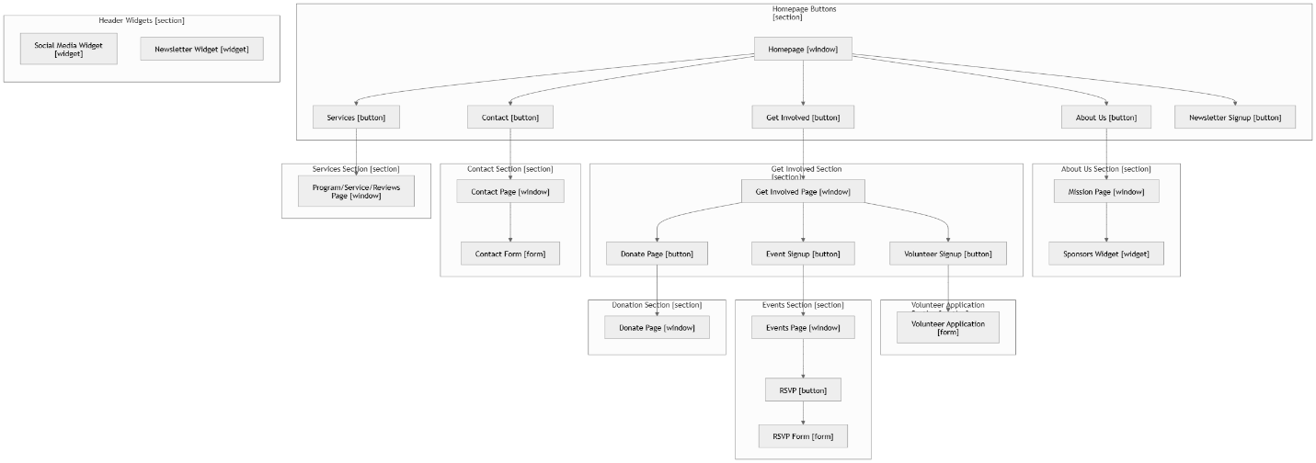

## Screen Layouts:

#### Contact Form

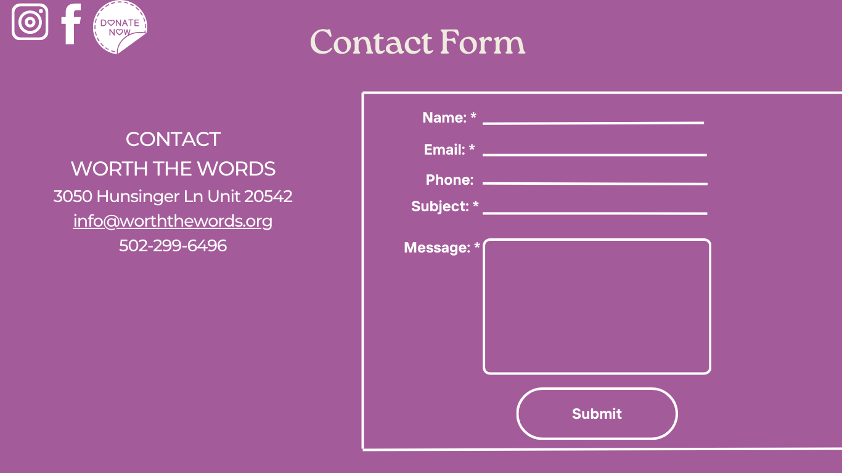

As shown in the prototype, all fields in the contact form will be empty by default. All of the fields will be required for a submission to process. With one exception, the end user may leave the phone number field blank if they’d like. After filling out the fields the submit button sends the information to the backend.

#### Newsletter Form

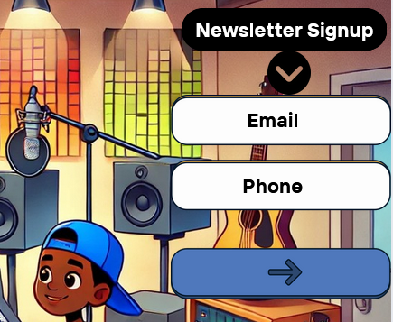

The newsletter form shows up on multiple different pages including the home page and the Stay Connected page. The end user has the option to input either their email or phone number, for the form to submit one of the fields has to be filled. After submission, the data is sent to a Wix dashboard containing all of the Newsletter submissions.

#### RSVP Form

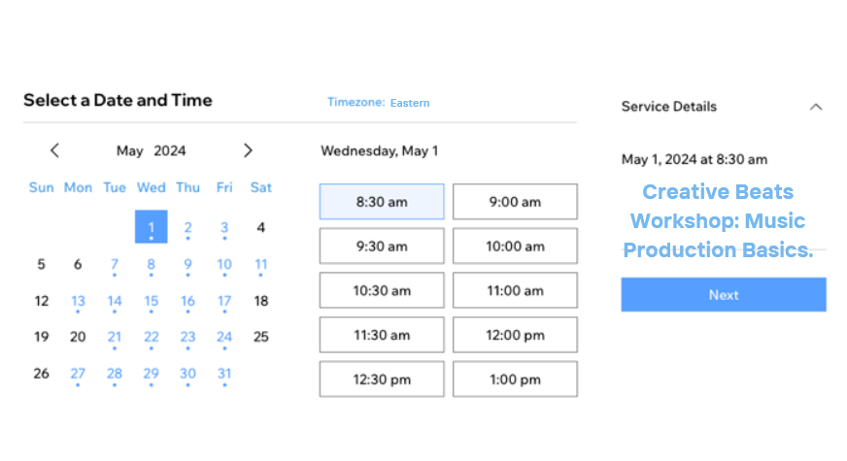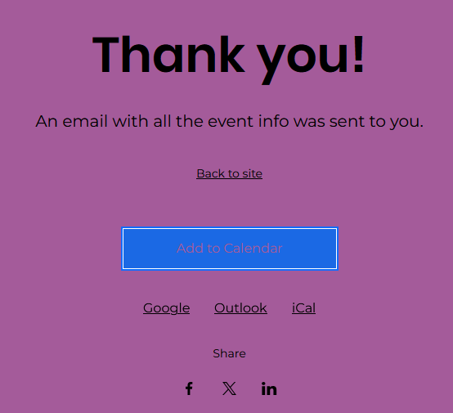

Using the RSVP form, the end user can select the event or service date, the time, view the details of the event/service, and can then click next to confirm their RSVP. After confirming the RSVP, the submission will be sent to a dashboard that contains the full list of guests. After confirming, the end user may also add the event to whichever calendar app of their choice.

#### Application Form

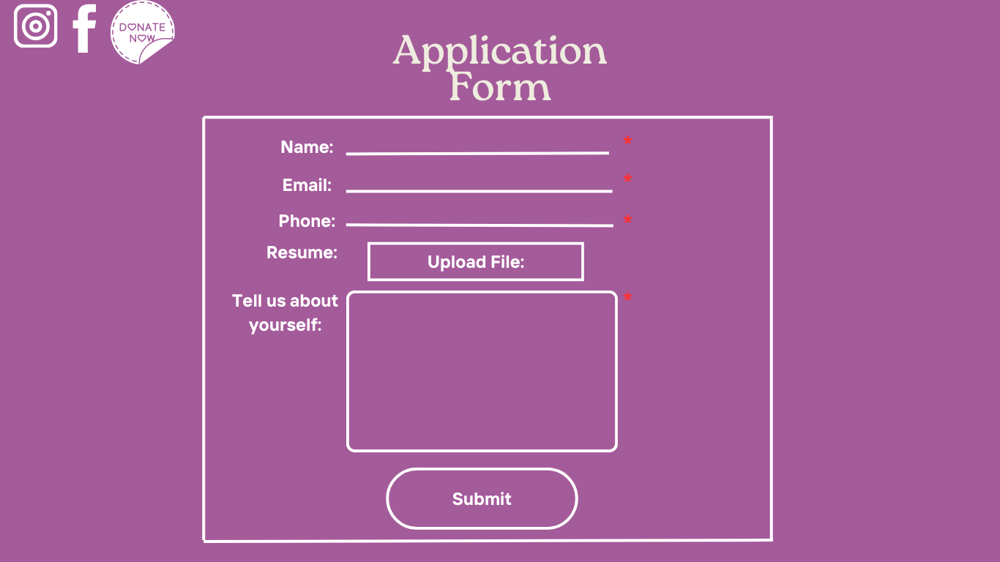The application form requires the end user to enter their name, email address, phone number, and a custom message about themselves. There’s also a resume field that allows the user to attach a resume to their submission, but that is not a required field. After submission, the user’s information is sent to the Wix backend and is stored in a dashboard containing all of the current application form submissions.

### 3.3B Data Output Screens

#### Contact/Application Submissions

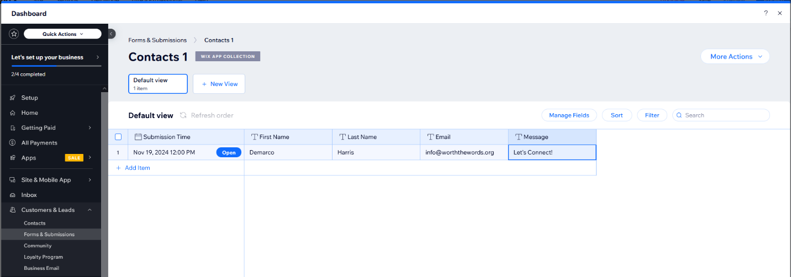After an end user submits a contact request, their submitted information is sent to the Wix backend which hosts a dashboard that displays each contact submission. If needed, the administrator can create separate views that showcase different filters or sorted information. The dashboard can also be exported to a CSV if needed.

#### Newsletter Submissions

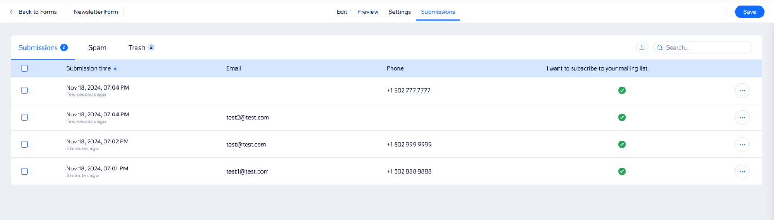After an end user enters submits either their email address or phone number through the newsletter form, their information is sent to a dashboard in the Wix backend. Each submission’s submission time, email address, and phone number can be viewed from the dashboard. Along with this, there’s a spam filter and trash tab in case the administrator deletes an item and wants to recover it.

#### RSVP Submissions

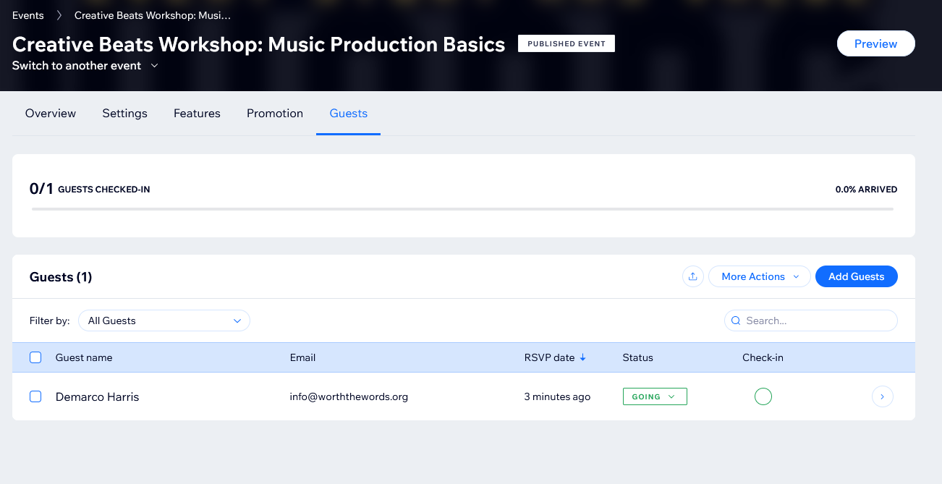After the end user submits the RSVP form, their registration is stored in the event dashboard in the guest tab. The registration contains the guests name, email, RSVP date, status, and check-in status. If the number of guests is limited, then the user would not have been able to submit the RSVP form. Each guest can check into the event and the administrator will be notified of the amount of checked in guests through the dashboard. The administrator can also export the guest list or utilize email marketing for the guests.

#### Application Submissions

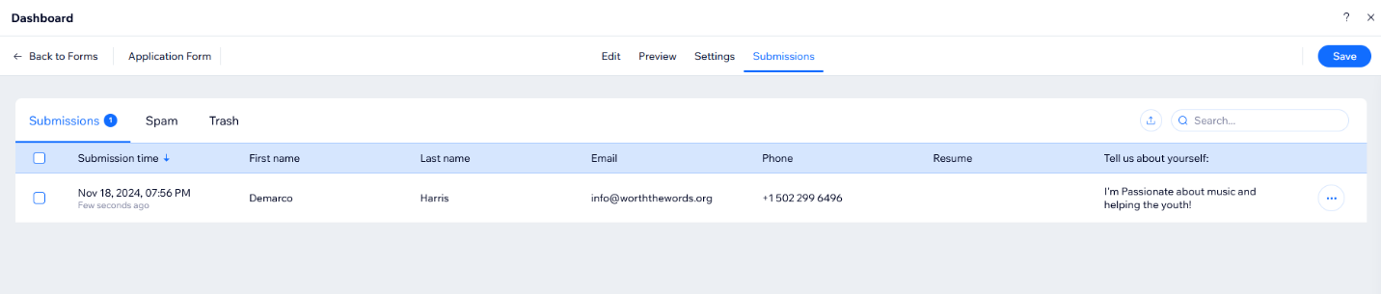After an end user submits their volunteer application form, their information is sent to the Wix backend that displays a dashboard. The dashboard contains the application’s submission time, the user’s first name, last name, email, phone number, resume (if submitted), and a custom message from the user. Similar to the newsletter submissions, the dashboard has a spam and trash filter for application submissions.

# Physical Architecture Design:

Our team decided that the best approach for the "Worth The Words" website redesign was to fully integrate the new design within the existing website, avoiding the need for a subdomain or separate platform. The WIX platform was chosen for its ease of use, offering a built-in content management system (CMS), payment management, and hosting capabilities. This allows the website to be managed without requiring extensive technical expertise.

Initially, we explored other CMS options like WordPress or Drupal. However, after discussions with the stakeholders, we decided that WIX would offer a more efficient and cost-effective solution for the nonprofit’s needs. WIX’s native integration with PayPal will handle donation processing, and its cloud-based infrastructure will provide reliable performance without requiring separate hosting services. The website will feature a mobile-responsive design, ensuring accessibility on both desktop and mobile devices. Event management will be integrated using WIX’s existing capabilities, with additional tools like Eventbrite considered for larger, more complex events.

In terms of architecture, the main focus will be on optimizing usability for both content managers and users. This involves providing a seamless experience for volunteers, donors, and community members, ensuring they can easily navigate the site, donate, and register for events. By leveraging WIX’s comprehensive toolset, we are ensuring that "Worth The Words" can maintain its website without additional technical support, while also enhancing the user experience for all stakeholders.

## Initial Design View

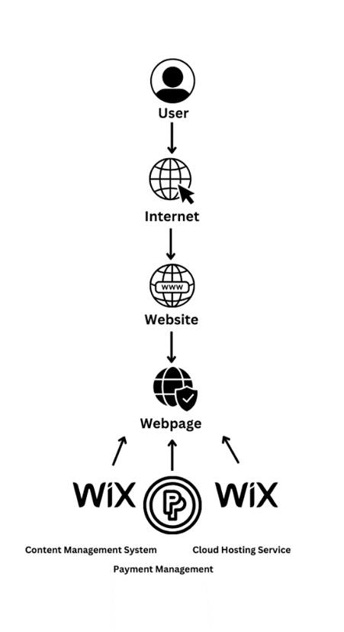

## Realistic Design View

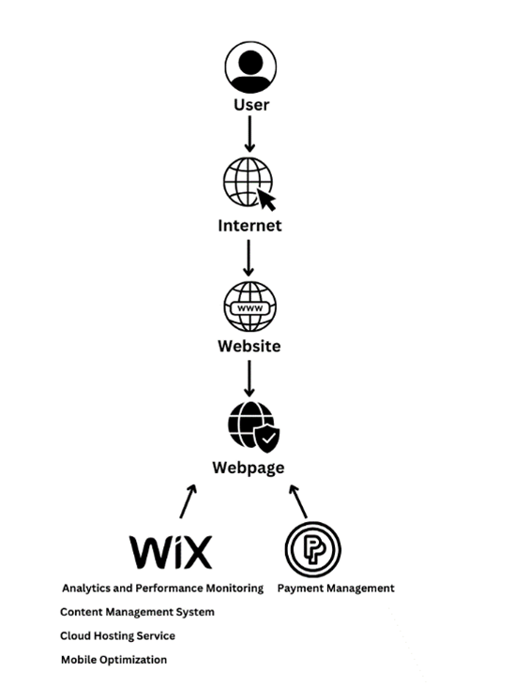

# Design Procedures for Security Concerns and Non-Functional Requirements:

Addressing the non-functional requirements for Worth the Words involves implementing robust procedures that ensure functionality, security, and reliability. The identified non-functional requirements include a sponsor banner, a reviews section, and a volunteer hour tracker. Special emphasis must be placed on security to protect the website's integrity and user trust while ensuring each feature operates effectively.

For the sponsor banner, which showcases logos and details of supporting organizations, it is critical to establish content verification procedures to ensure the accuracy and authenticity of the uploaded information. This includes verifying sponsor names, logos, and URLs before uploading to prevent the display of incorrect or fraudulent content. Secure hosting of sponsor-related images and links is essential to avoid tampering, while access to manage the sponsor banner should be restricted to administrators. During the detailed design phase, input validation mechanisms should be integrated to block potential malicious scripts, and all external links should mandate the use of HTTPS protocols to ensure secure user connections.

The reviews section, designed to display testimonials from youth participants and parents, necessitates stringent content moderation to filter out inappropriate or harmful submissions. To uphold privacy standards, reviews must be collected and displayed in compliance with data protection regulations, with explicit consent obtained from contributors. Additionally, offering an option for anonymous submissions can increase participation while safeguarding identities. To address these requirements during the design stage, CAPTCHA tools should be deployed to block spam or bot-generated content. Reviews should be stored securely in Wix’s backend with encryption for both storage and transmission.

The volunteer hours widget, which displays the total hours worked by volunteers, requires measures to maintain data accuracy and integrity. Real-time updates should be designed to handle high traffic without disruptions, and regular backups of volunteer hour data should be performed to prevent loss. During the detailed design phase, access to modify the widget must be tightly controlled using authentication measures. If APIs are used to fetch or update the data, they should be secured with authentication tokens and encrypted transmissions. Validating the accuracy of the data before display ensures that the information presented is both reliable and trustworthy.

Security measures are a cornerstone for addressing these non-functional requirements. Authentication and authorization protocols must restrict access to sensitive features, ensuring only administrators can manage content. Implementing HTTPS across the site will protect data transmitted between users and the server, enhancing security and user confidence. Regular updates to Wix plugins and security settings will mitigate vulnerabilities, while error-handling mechanisms will prevent data leaks and provide a seamless user experience. By integrating these practices into the detailed design, Worth the Word's can meet its non-functional requirements but also maintain the trust and satisfaction of its users, sponsors, and contributors.

# Gantt Chart

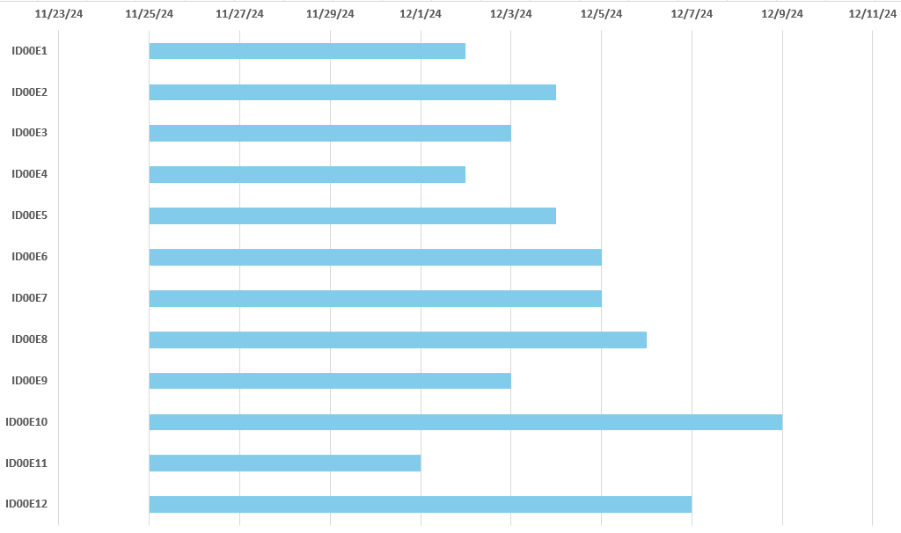  
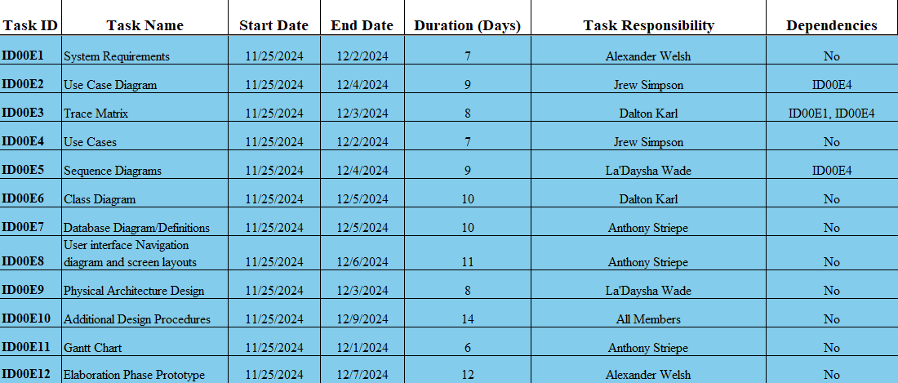

# Elaboration Phase Prototype:

Song Catalog

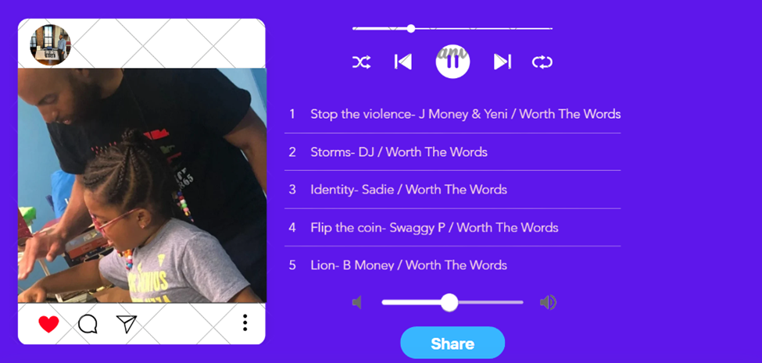Donation Screen

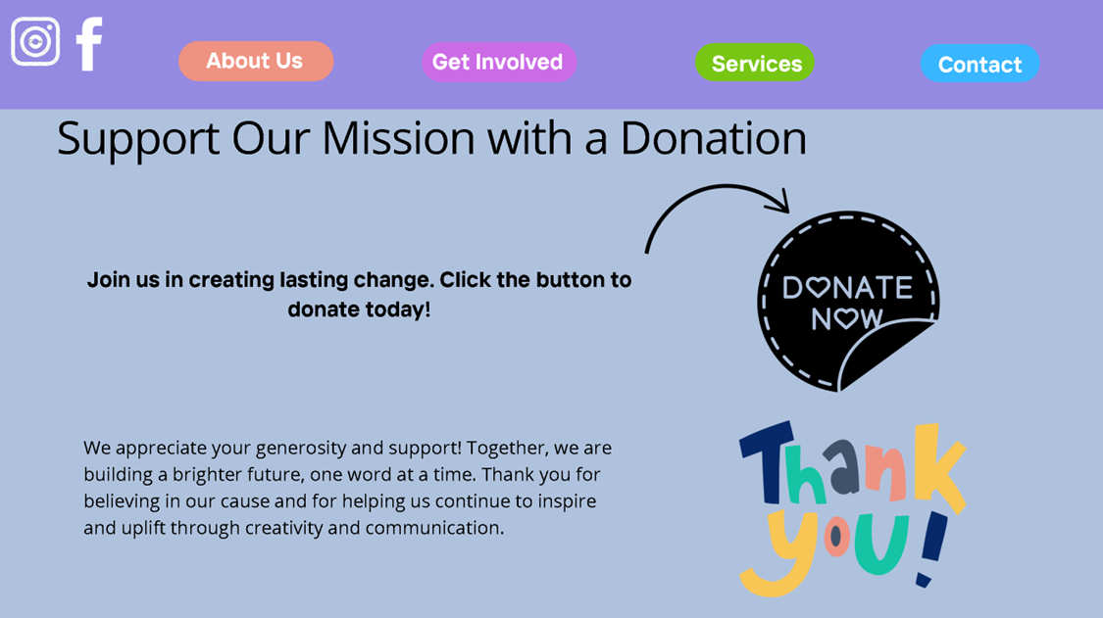

Donation System

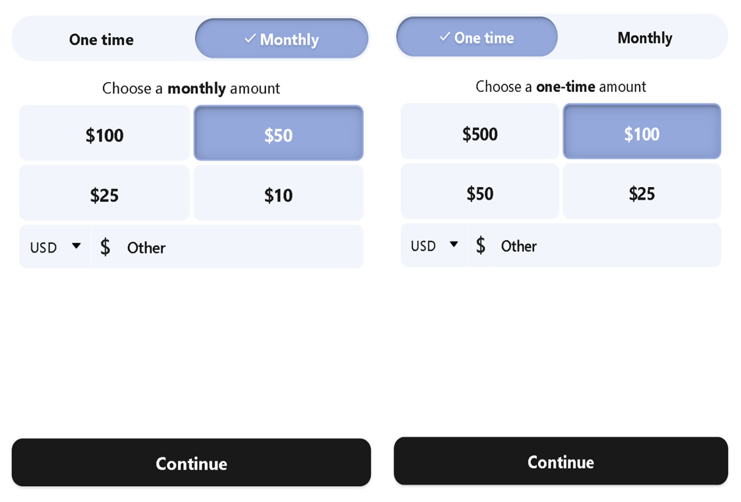Newsletter Signup Dropdown

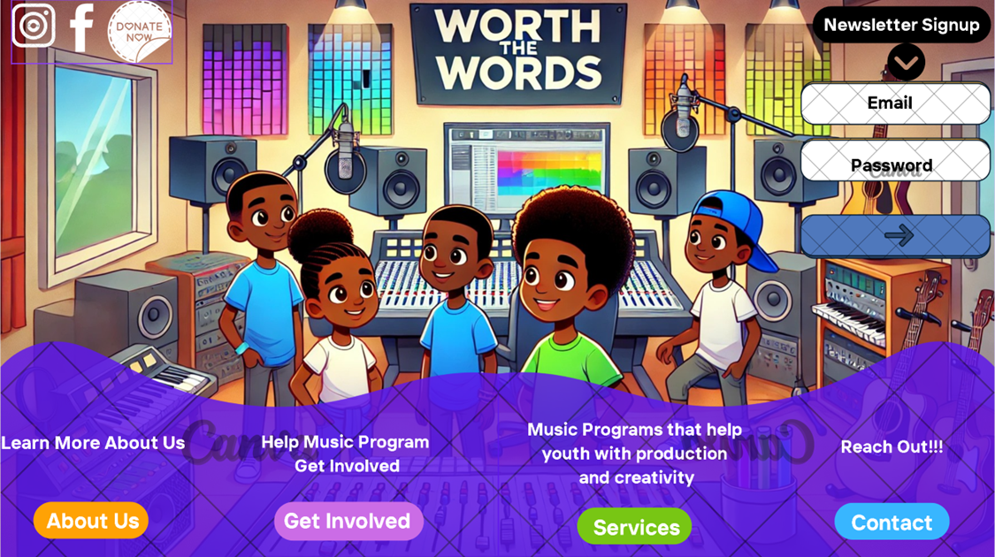

Reviews Section

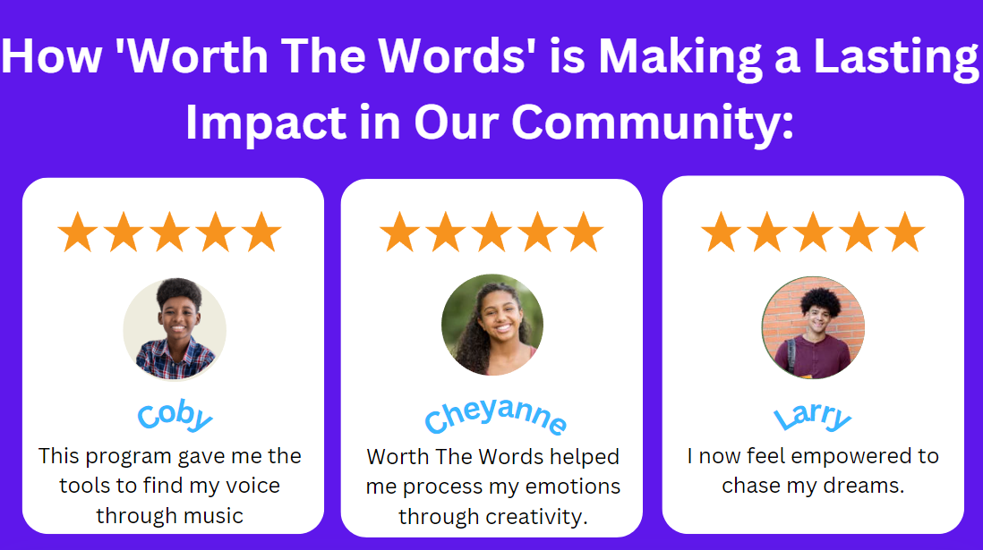Social Media Integration

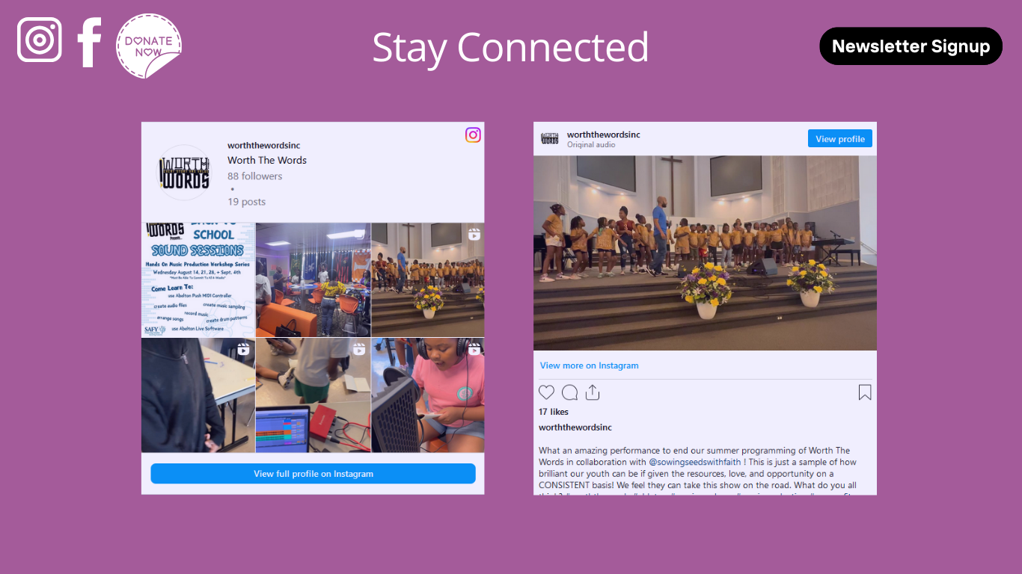

View Program/Workshop Information 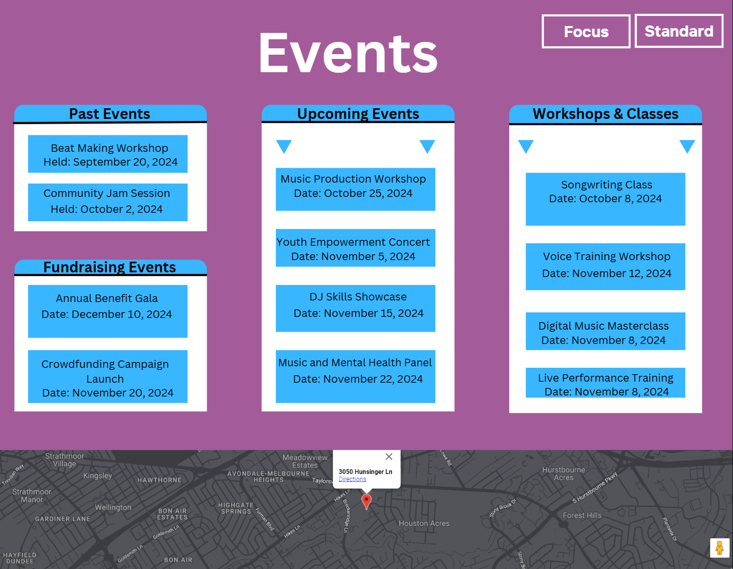

Interacts With Calendar

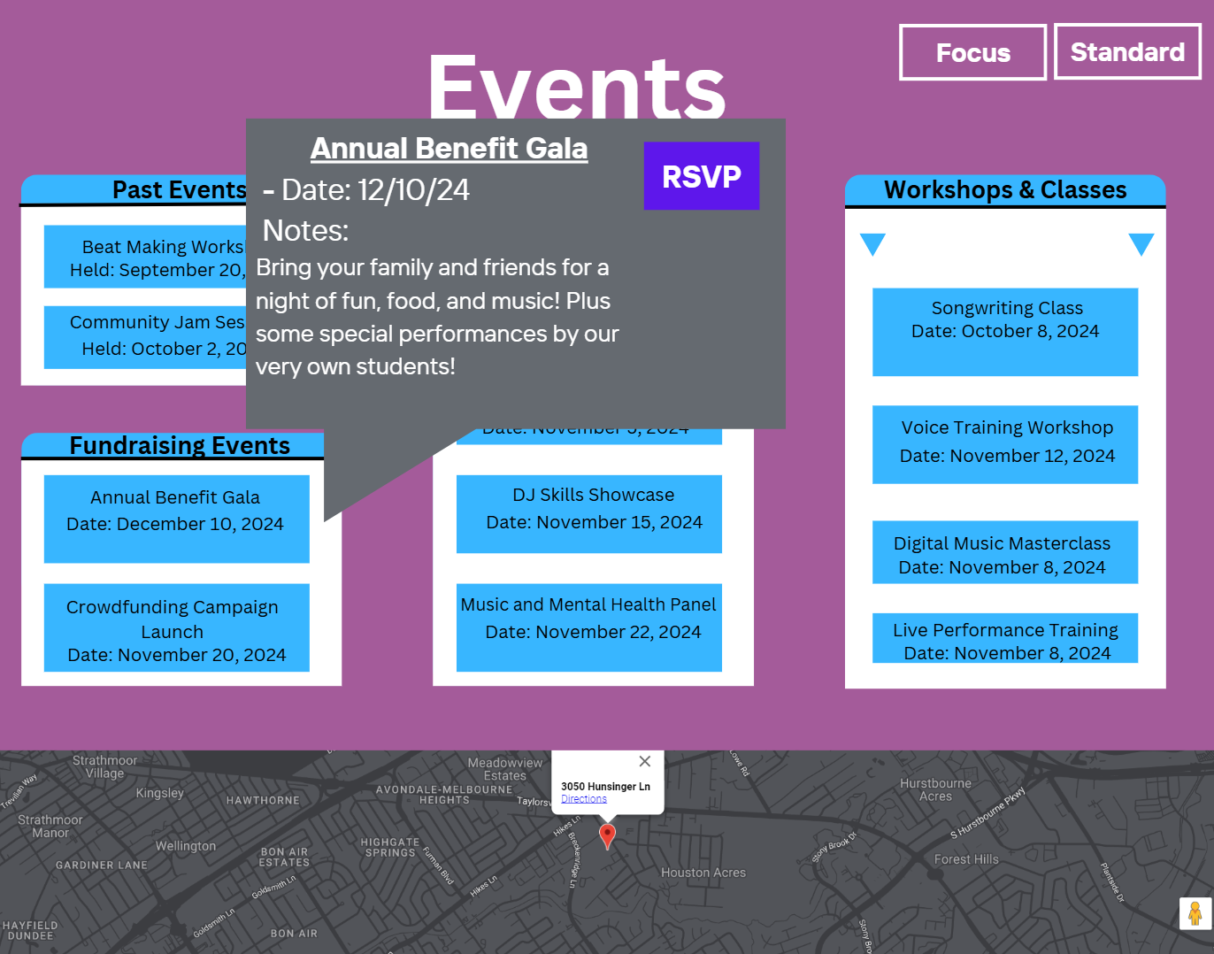

Fill Out Contacts 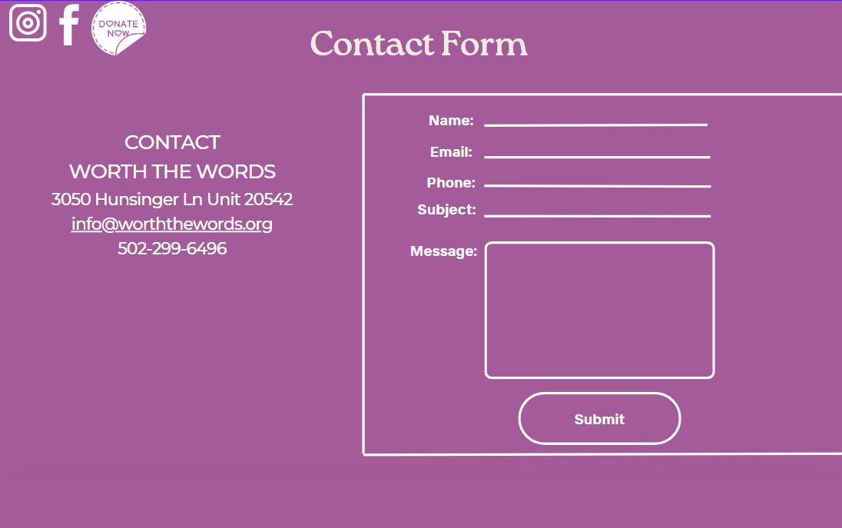

View Contact Submissions

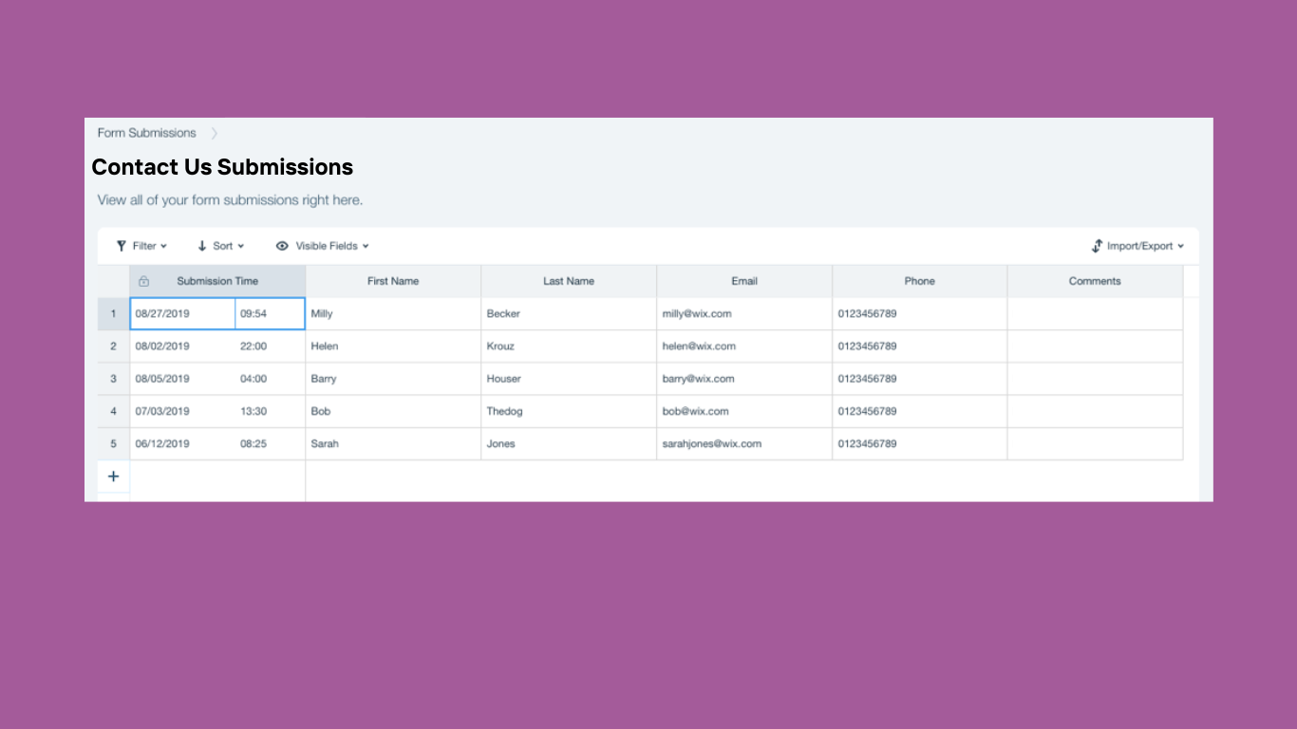  
  
  
Modify Contact Form  
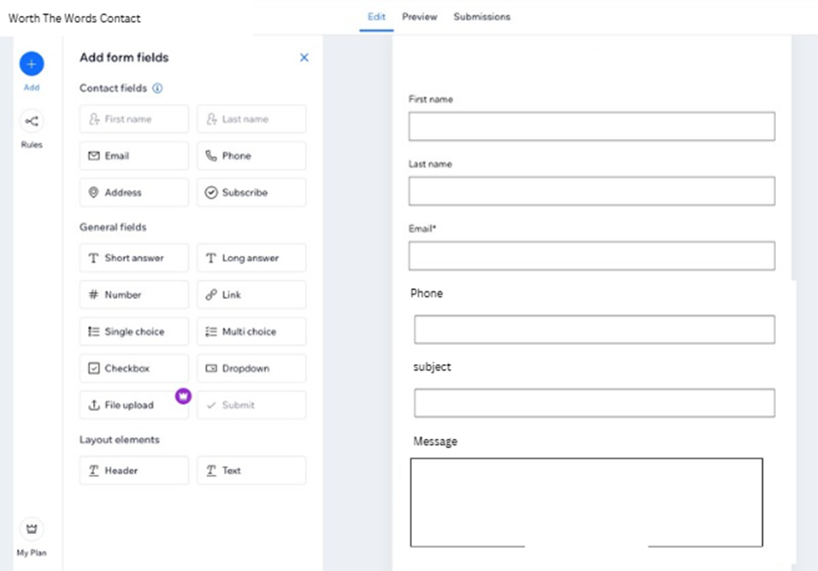

View Mission Statement  
  
Filling Out Volunteer Form  
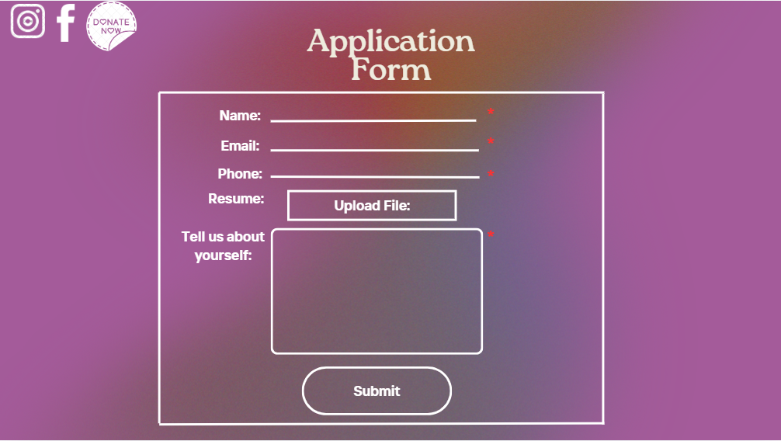

View Volunteer Hours  
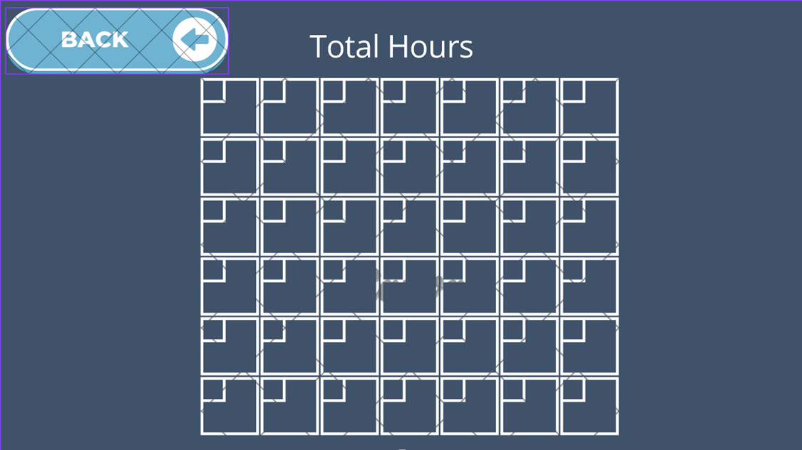

About Us and Sponsors  
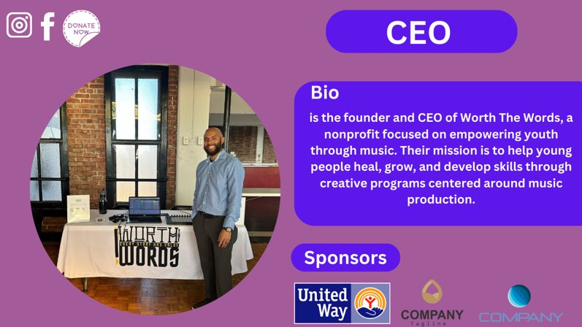

Admin View Data  
